**A Mini Project Report on**

**“CLASS CONNECT - Notice, Submission, Forum”**

**Submitted in partial fulfillment of the requirement for**

**Degree in Bachelor of Engineering (Computer Engineering)**

**By**

|  |  |  |
| --- | --- | --- |
| NOTICE | SUBMISSION | FORUM |
| Amarja Deshpande - 101411  Alvina Malpan - 101428  Meghana Mathew 101431  Rugved Mone - 101434  Anurima Padwal - 101438 | Pranali Kanere - 101422  Manish Manepalli - 101429  Vishal Patil - 101440  Sinimol Babu - 101456  Taruni Rajan - 101458 | Sumit Das - 101410  Kartik Jain - 101420  Korol Dhanda - 101425  Steve Menezes - 101432  Paritosh Nichat - 101436 |

**Guided by**

Mrs. Smita Dange



**Department of Computer Engineering**

**Fr.Conceicao Rodrigues Institute of Technology**

Sector 9A, Vashi, Navi Mumbai - 400703

**University of Mumbai**

**SH 2016**

**CERTIFICATE**

This is to certify that the project entitled

**CLASS CONNECT - NOTICE, SUBMISSION, FORUM**

**Submitted By**

|  |  |  |
| --- | --- | --- |
| NOTICE | SUBMISSION | FORUM |
| Amarja Deshpande - 101411  Alvina Malpan - 101428  Meghana Mathew - 101431  Rugved Mone - 101434  Anurima Padwal - 101438 | Pranali Kanere - 101422  Manish Manepalli - 101429  Vishal Patil - 101440  Sinimol Babu - 101456  Taruni Rajan - 101458 | Sumit Das - 101410  Kartik Jain - 101420  Korol Dhanda - 101425  Steve Menezes - 101432  Paritosh Nichat - 101436 |

In partial fulfillment of degree of **B.E. (V.Sem)** in **Computer Engineering** for term work of the

Mini project is approved

**Internal Guide Comp-Co ordinator**

**_________________ __________________**

**Date:- College Seal**

**INDEX**

|  |  |  |
| --- | --- | --- |
| **Sr.No.** | **Topic** | **Page**  **No.** |
| 1. | About Mini Project | 4 |
| 2. | Working | 5 |
| 3. | Block Diagram | 7 |
| 4. | Database Design | 8 |
| 5. | Coding | 12 |
| 6. | Testing | 67 |
| 7. | Result | 68 |

1. **ABOUT MINI PROJECT**

Our mini project for our “Web Technologies” course, titled “CLASS CONNECT”, is a website intended to revolutionize current learning methods in our college. The website has three major modules: Notice, Forum and Submission. The Notice module has a teacher portal as well as a student portal. The teacher can log in using a unique “teacher ID” and password. Then he/she can proceed to post a notice on the site which would be categorized into any of the following categories: Academics, Exam Cell, Placements, Competitions, and Miscellaneous. The student can log in using roll number and password and can view the notices.

The Forum module provides a platform for students and teachers to log in and interact with each other by posting and answering course related questions. A user (student or a teacher) can post a question. Other users can view or answer the question as well as “vote” the answer posted by other users. The “vote” feature results in an increment in the number of “points” an answer has. This module ensures a sharing of ideas and enables all students and teachers to be a part of the learning process.

The idea for Submission module was developed with the aim to streamline the assignment submission and grading process. Rather than the teacher being swamped with bundles of assignments to correct and grade, our module provides a platform where the teacher posts an assignment question online, with an associated deadline. The student views it, completes the assignment and uploads it in the required pdf format. The teacher can now grade the assignment as well as add remarks and send the corrected assignment to the student.

**2. WORKING**

**2.1 NOTICE**

The Notice module has a student portal as well as a teacher portal. The teacher logs in to his/her profile using a unique Teacher Id and a password. The teacher can create a new notice by selecting the branch and semester and providing a topic and description about the notice. He/she can also attach files, if required. The previously posted notices can be viewed.

Once the student logs in to his/her account, he/she can view all the notices along with its category and the name of the teacher issuing it. On selecting a notice, the student gets its description and (any) attached file which can be downloaded. The notices are classified as per the categories: Academics, Exam Cell, Placement, Holidays, Competitions and Others.

**2.2 SUBMISSION**

The Submission module has a student portal as well as a teacher portal. The teacher logs in to his/her profile using a unique Teacher Id and a password. Upon selecting the semester, the teacher gets a list of subjects taught by him/her for that branch and semester. On selecting the particular subject, the teacher is provided with two options.

One option is to create a new assignment question for the intended class. The teacher enters a topic and de­scription of the assignment, and can also attach a file if required. The teacher also assigns a deadline. Another option is to view the previous assignments. This allows the teacher to view a list of all previous assignments given by him/her for that subject. The teacher can view a list of assignments submitted by the students and also correct and grade each assignment. Then the teacher sends the corrected assignments to the students.

The student logs in to his/her profile using his/her roll no. and password. Here there are 3 options. The first is the “To be submitted” option. Here the student can view a list of al pending assignments. The second option is “Checked” assignments, which shows a list of checked assignments by the teacher, along with the remark and grade. The third option, “Unchecked” allows the student to view a list of all submitted, but unchecked assignments.

The constraint is that the student has to submit the assignment within the given deadline. Otherwise, the submit option is disabled.

**2.3 FORUM**

As the user successfully logs in, he will be directed to the homepage. In the homepage, he will have two set of options:

a) student branch questions

b) all questions irrespective of branch .In the student branch questions, there will be a stack-wise arrangements of the subjects. On clicking on any subject, he would be taken to the page which contains that subject related questions. Here, the questions are listed along with the answers and the responses of all the answers are also shown to the user.

Here, he will have three options: a) like/dislike a question b) upvote /downvote an answer c)add his own question/answer. For each question and answer response, he needs to click on the submit button,which will add the responses to forum immediately via AJAX .The user ID is stored as the session variable in the browser, and the user cannot change it and it is unique for each user. Therefore the user ID remains constant.

**Adding an answer**: The user selects a subject and each subject has a unique ID .Now, this subject ID is passed to the server instead of sending the name.As this subject ID is unique,the server can easily access the database using subjectID and get the required subject ID.Once the user has selected the subject, he can directly write the answer and click on submit.

Using a XMLhttp request, it is send to the server.At the server side, these is inserted into database along with the userID.

**Adding a question:** This section is present in the question & answer page where the questions as well as its answers, which were previously writen, are listed. Here, it automatically takes the subject ID and question ID via URL using GET method.Because the subject ID and question ID is obtained by this, the user does not need to enter that data once more.User then just needs to type the answer and submit it.This answer is then submitted and inserted into the database.

1. **BLOCK DIAGRAM**

CLASS CONNECT

NOTICE

STUDENT MODULE

STUDENT MODULE

TEACHER MODULE

STUDENT

MODULE

USER

STUDENT

MODULE

TEACHER MODULE

SUBMISSION

FORUM

1. **DATABASE DESIGN**

**4.1 NOTICE MODULE**

**NOTICE**

|  |  |  |
| --- | --- | --- |
| **NAME** | **DATATYPE** | **CONSTRAINTS** |
| Id | int(11) | PRIMARY KEY |
| Branch | varchar(20) |  |
| Sem | int(11) |  |
| Teacher | varchar(20) |  |
| Topic | varchar(20) |  |
| Description | varchar(400) |  |
| File | varchar(30) |  |
| Date | varchar(15) |  |

**STUDENT**

|  |  |  |
| --- | --- | --- |
| **NAME** | **DATATYPE** | **CONSTRAINTS** |
| Roll | varchar(6) | PRIMARY KEY |
| Name | varchar(20) |  |
| Password | varchar(20) |  |
| Branch | varchar(20) |  |
| Semester | tinyint(4) |  |

**TEACHER**

|  |  |  |
| --- | --- | --- |
| **NAME** | **DATATYPE** | **CONSTRAINTS** |
| Tid | varchar(10) | PRIMARY KEY |
| Name | varchar(20) |  |
| Password | varchar(20) |  |

**CURRICULUM**

|  |  |  |
| --- | --- | --- |
| **NAME** | **DATATYPE** | **CONSTRAINTS** |
| Branch | varchar(20) |  |
| Sem | int(11) |  |
| Subject | varchar(20) | PRIMARY KEY |
| sub2 | varchar(20) |  |
| sub3 | varchar(20) |  |
| sub4 | varchar(20) |  |
| sub5 | varchar(20) |  |
| sub6 | varchar(20) |  |

**4.2 SUBMISSION MODULE**

**STUDENT**

|  |  |  |
| --- | --- | --- |
| **NAME** | **DATA TYPE** | **CONSTRAINTS** |
| roll | int(6) | PRIMARY KEY |
| name | varchar(25) |  |
| password | varchar(10) |  |
| branch | varchar(10) |  |
| semester | varchar(5) |  |

**TEACHER**

|  |  |  |
| --- | --- | --- |
| **NAME** | **DATA TYPE** | **CONSTRAINTS** |
| tid | varchar(10) | PRIMARY KEY |
| name | varchar(25) |  |
| password | varchar(10) |  |
| branch | varchar(10) |  |

**TEACHER_SUBMISSION**

|  |  |  |
| --- | --- | --- |
| **NAME** | **DATA TYPE** | **CONSTRAINTS** |
| assign_id | int(5) | PRIMARY KEY |
| branch | varchar(10) |  |
| semester | varchar(5) |  |
| tid | varchar(10) |  |
| subject | varchar(25) |  |
| description | varchar(255) |  |
| mode | enum(‘softcopy’,’hardcopy’) |  |
| file | Longblog |  |
| datetime | Date |  |
| deadline | Date |  |

**STUDENT_SUBMISSION**

|  |  |  |
| --- | --- | --- |
| **NAME** | **DATA TYPE** | **CONSTRAINTS** |
| roll | int(6) |  |
| branch | varchar(10) |  |
| semester | varchar(5) |  |
| assign_id | int(5) |  |
| attachment | Longblob |  |
| submit_date | Date |  |
| grade | enum(‘A’,’B’,’C’,’D’) |  |
| remarks | varchar(25) |  |
| status | varchar(10) |  |

**SUBJECTLIST**

|  |  |  |
| --- | --- | --- |
| **NAME** | **DATA TYPE** | **CONSTRAINTS** |
| branch | varchar(10) |  |
| semester | varchar(5) |  |
| subject | varchar(25) |  |
| taught_by_id | varchar(10) |  |

**4.3 FORUM**

**USER TABLE:**

|  |  |  |
| --- | --- | --- |
| **COLUMN-NAME** | **DATATYPE** | **CONSTRAINTS** |
| u_id | int(11) | PRIMARY KEY |
| uname | varchar(50) |  |
| Sem | int(11) |  |
| branch | varchar(50) |  |
| password | varchar(50) |  |
| Noq | int(11) |  |
| Noa | int(11) |  |

**ANSWERS TABLE:**

|  |  |  |
| --- | --- | --- |
| **COLUMN-NAME** | **DATATYPE** | **CONSTRAINTS** |
| a_id | int(11) | PRIMARY KEY |
| q_id | int(11) |  |
| s_id | int(11) |  |
| answers | varchar(1000) |  |
| upvotes | int(11) |  |
| downvotes | int(11) |  |
| u_id | int(11) |  |

**QUESTIONS TABLE:**

|  |  |  |
| --- | --- | --- |
| **COLUMN-NAME** | **DATATYPE** | **CONSTRAINTS** |
| q_id | int(11) | PRIMARY KEY |
| s_id | int(11) |  |
| questions | varchar(500) |  |
| Vote | int(11) |  |
| u_id | int(11) |  |

**SUBJECTS TABLE:**

|  |  |  |
| --- | --- | --- |
| **COLUMN-NAME** | **DATATYPE** | **CONSTRAINTS** |
| s_id | int(11) | PRIMARY KEY |
| s_name | varchar(50) |  |
| Sem | int(11) |  |
| branch | varchar(50) |  |

1. **CODING**

**5.1 NOTICE MODULE**

**TEACHER PORTAL**

**//noticeentry.php - Displays the form to be displayed when Teacher has successfully logged in; provides fuction to create a new notice and calls ‘submitnotice.php’ upon SUBMIT.**

<?php

echo"<title> UPLOAD NOTICE </title>

<body>

<form id='notice' action='submitnotice.php' method='POST' enctype='multipart/form-data'>

BRANCH

<select name='branch' id='branch' >

<option value='default'>Select </option>

<option value='comps'>comps</option>

<option value='elec'>elec</option>

<option value='mech'>mech</option>

<option value='it'>it</option>

<option value='extc'>extc</option>

<option value='all'>all</option>

</select>

<br>

SEMESTER

<select name='sem' name='sem' >

<option value='default'>Select </option>

<option value='1'>1</option>

<option value='2'>2</option>

<option value='3'>3</option>

<option value='5'>5</option>

<option value='6'>6</option>

<option value='7'>7</option>

<option value='8'>8</option>

<option value='0'>all</option>

</select>

<br>

TOPIC<input type='text'id='topic'name='topic'><br>

DESCRIPTION<input type='text'id='desc'name='desc'style='height:150px; width:150px;'><br>

UPLOAD(if required)<input type='file'id='file' name='file'><br>

<input type='submit' value='POST NOTICE'>

</form>

</body>";

?>

**//submitnotice.php - Contains server side as well as client side code for the webpage that enables the teacher to create and upload a new notice**

|  |
| --- |
| <?php session_start(); |
| $con=mysqli_connect('localhost','root','','wtl'); |
| $tname=$_SESSION["teacher_name"]; |
|  |
|  |
| $branch=$_POST['branch']; |
| $sem=$_POST['sem']; |
| $topic=$_POST['topic']; |
| $desc=$_POST['desc']; |
| $filename='0.x'; |
| $filename=$_FILES["file"]["name"]; |
| if($filename!='0.x') |
| { |
| $type=$_FILES["file"]["type"]; |
|  |
| move_uploaded_file($_FILES["file"]["tmp_name"],"files/".$_FILES["file"]["name"]); |
| } |
|  |
| $time=time(); |
|  |
| $date=date("d-m-Y",$time); |
|  |
|  |
| $query="insert into notice values ('','$branch','$sem','$tname','$topic','$desc','$filename','$date');"; |
| if(mysqli_query($con,$query)) |
| { |
| echo "<script type='text/javascript'>alert('Your notice has been sent to the students');</script>"; |
|  |
| $con=mysqli_connect('localhost','root','','wtl'); |
| $name=$_SESSION["teacher_name"]; |
| $query2=" select * from notice where teacher='$name'; "; |
| $result2=mysqli_query($con,$query2); |
| $numrows=mysqli_num_rows($result2); |
| $count =1; |
|  |
|  |
|  |
|  |
| echo"<!doctype html> |
| <!DOCTYPE html> |
| <html> |
| <head> |
| <title>notice</title> |
| <meta charset='utf-8'> |
| <meta name='viewport' content='initial-scale=1, width=device-width'> |
| <link rel='stylesheet' href='http://maxcdn.bootstrapcdn.com/bootstrap/3.3.7/css/bootstrap.min.css'> |
| <script src='https://code.jquery.com/jquery-3.1.0.min.js'></script> |
| <!--<script src='https://ajax.googleapis.com/ajax/libs/jquery/1.12.4/jquery.min.js'></script> --> |
| <script src='http://maxcdn.bootstrapcdn.com/bootstrap/3.3.7/js/bootstrap.min.js'></script> |
| <!-- Fonts --> |
| <link href='https://fonts.googleapis.com/css?family=Nunito' rel='stylesheet'> |
| <link href='https://fonts.googleapis.com/css?family=Lobster' rel='stylesheet'> |
| <link href='https://fonts.googleapis.com/css?family=Cuprum:700' rel='stylesheet'> |
| <link href='https://fonts.googleapis.com/css?family=Play' rel='stylesheet'> |
| <link href='https://fonts.googleapis.com/css?family=Exo+2' rel='stylesheet'> |
| <link href='https://fonts.googleapis.com/css?family=Amaranth' rel='stylesheet'> |
| <!-- Date picker script --> |
| <script type='text/javascript' src='https://cdnjs.cloudflare.com/ajax/libs/bootstrap-datepicker/1.4.1/js/bootstrap-datepicker.min.js'></script> |
| <link rel='stylesheet' href='https://cdnjs.cloudflare.com/ajax/libs/bootstrap-datepicker/1.4.1/css/bootstrap-datepicker3.css'/> |
|  |
| <!-- Calender Link and Js files --> |
| <link href='css/responsive-calendar.css' rel='stylesheet'> |
| <style type='text/css'> |
| .drop{ |
|  |
| background-color: #abcdef; |
| } |
| .drop:hover{ |
|  |
| } |
| #colnav{ |
| color:#bab5b4; |
| } |
|  |
|  |
| nav{ |
| padding-top: 0.5%; |
| height:10%; |
| width:100%; |
| background-color: #CFD8DC; |
| } |
|  |
| .navbar-brand{ |
| font-family: 'Lobster', cursive; |
| font-size: 2.5em; |
| color:#000000; |
| } |
| li{ |
| font-family: 'Nunito', sans-serif; |
| color: #fff; |
| } |
| ul.navbar-nav{ |
| color:#000; |
| } |
| ul.navbar-nav >li:hover{ |
| border-bottom: 5px solid #000; |
| background-color: #fff; |
| } |
| a:hover, a:focus { |
| color: #000000; |
| } |
|  |
| #header{ |
| font-family: 'Cuprum', sans-serif; |
| font-size: 2.2em; |
| text-align: center; |
| text-shadow: 1px 1px 4px #000; |
| background-color: #ffffff; |
| color:#fff; |
| opacity: 0.9; |
| } |
|  |
| table.submission-table > tr{ |
| font-family: 'Play', sans-serif; |
|  |
| } |
| .modal-header{ |
| background-color: #675682; |
| color:#fff; |
| } |
| .status-box{ |
| background-color:rgba(95,15,78,0.75); |
| z-index: 1; |
| text-align: center; |
| /* -webkit-filter : hue-rotate(180deg); |
| filter : hue-rotate(180deg); */ |
| } |
| .stat_container{ |
| float:left; |
| margin-top: 5%; |
| margin-left: 5%; |
| color:#fff; |
| padding-left: 5%; |
| padding-bottom: 7%; |
| } |
| .stat_caption{ |
| color:#fff; |
| font-family: 'Amaranth', sans-serif; |
| font-size:2em; |
| } |
| .status{ |
| border-radius: 50%; |
| text-align: center; |
| padding-top: 20%; |
| padding-bottom: 0; |
| color:#fff; |
| background-color: rgba(95,15,78,0.8.5); |
| box-shadow: 8px 5px 5px rgba(95,15,78,0.9); |
| font-family: 'Exo 2', sans-serif; |
| font-size: 3.5em; |
| border: 5px solid #000; |
| min-height: 150px; |
| min-width:150px; |
| float:left; |
| margin-bottom: 10%; |
|  |
| } |
| html { |
| background: url(fcrit.jpg) no-repeat center center fixed; |
| -webkit-background-size: cover; |
| -moz-background-size: cover; |
| -o-background-size: cover; |
| background-size: cover; |
| opacity: 0.9; |
| } |
| button{ |
| color:#fff; |
| background-color: #e52a6f; |
| } |
| .hamburger{ |
| color:#fff; |
| background-color: #000; |
| font-size: 2em; |
| } |
| #wrapper { |
| height: 100%; |
| width: 200px; |
| overflow: auto; |
| } |
|  |
| </style> |
| <script src='http://ajax.googleapis.com/ajax/libs/jquery/1.7/jquery.js'></script> |
| <script src='http://malsup.github.com/jquery.form.js'></script>"; |
|  |
| echo" |
| <body bgcolor='#abcdef' > |
| <nav class='navbar navbar-fixed-top' id='my-navbar'> |
| <div class='container'> |
| <div class='navbar-header' style='float:left;'> |
| <button type='button' class='navbar-toggle' data-toggle='collapse' data-target='#colnav'> |
| <span class='icon-bar hamburger'></span> |
| <span class='icon-bar hamburger'></span> |
| <span class='icon-bar hamburger'></span> |
| </button> |
| <a href='#' class='navbar-brand pull-left' style='margin-left:-99px;'>Class Connect</a> |
| </div> |
| <div class='collapse navbar-collapse' style='background-color:#CFD8DC' id='colnav'> |
| <button type = 'button' class = 'btn btn-default contrastEffect' style='float:right; |
| height:36px; width:100px; margin-top:7px; margin-right:-50px' |
| data-toggle = 'modal' data-target = '#profileModal'>Profile <span class = 'glyphicon glyphicon-user'> |
| </span></button> |
| <div style=' margin-right:80px;'><button type='button' style='float:right;' class='btn navbar-btn navbar-right' |
| data-toggle='modal' data-target='#confirm-lo'>Logout <span class='glyphicon glyphicon-log-out'> |
| </div> |
| </span></button> |
| <ul class='nav navbar-nav' style='margin-left:30px; font-size:18px; color:#000; border-radius:20%' > |
| <li><a href='#'>Home</a></li> |
| <li><a href='#'>Page 1</a></li> |
| <li><a href='#'>Page 2</a></li> |
| </ul> |
|  |
| <a href='teacherportal.php' class='btn btn-danger ' style='float:right;margin-top:8px; margin-right:13px; ' > |
| <span class='glyphicon glyphicon-edit'> |
| </span> Compose</a> |
| <input type='text' style='width:200px; margin-top:8px; float:right; margin-right:13px; ' |
| class='form-control' id='keyword' placeholder='Search'> |
| </div> |
| </div> |
| </nav> |
| <div class='modal fade' tabindex='-1' id='confirm-lo'> |
| <div class='modal-dialog modal-md'> |
| <div class='modal-content'> |
| <div class='modal-header'> |
| <button type='button' class='close' data-dismiss='modal'> |
| <span>&times;</span> |
| </button> |
| <h4 class='modal-title'><p>Are you sure you want to Logout?<p></h4> |
| </div> |
| <div class='modal-body'> |
| <center> |
| <a href='first.html'class='btn btn-default btn-md' >Yes</a> |
| &nbsp;&nbsp;&nbsp; |
| <button type='button' class='btn btn-default btn-md' data-dismiss='modal'>No</button> |
| </center> |
| </div> |
| </div> |
| </div> |
| </div> |
|  |
|  |
| <!--left side div--> |
| <div class='col-sm-12 col-md-6' style='margin-left:-1.6%;margin-right: -0.7%' > |
| <div class='container-fluid' style='margin-top:60px;float:left'> |
| <div class='modal-dialog'> |
| <div class='modal-content' style='height:540px; width:140%; position: relative;' |
| id='dynamicdiv'> |
| <div class='modal-header' id='header' style='background-color: #CFD8DC; |
| border:1px solid #1A237E; border-radius:5px; |
| color:#212121; font-family:Verdana;' >Create a Notice<!--Modal Header--> |
| </div> |
| <div id='content' style='font-size:20px;'> |
| <fieldset> |
| <form id='notice' class='form-horizontal' action='submitnotice.php' method='POST' |
| enctype='multipart/form-data'> |
| <br> |
| <br> |
| <!-- Form Name --> |
|  |
|  |
| <!-- Text input--> |
| <div class='form-group'> |
| <label class='col-md-4 control-label' for='topic'>TOPIC:</label> |
| <div class='col-md-4'> |
| <input id='topic' name='topic' type='text' placeholder='' class='form-control input-md' required=''> |
| </div> |
| </div> |
|  |
| <!-- Select Basic --> |
| <div class='form-group'> |
| <label class='col-md-4 control-label' for='branch'>BRANCH</label> |
| <div class='col-md-4'> |
| <select id='branch' name='branch' class='form-control'> |
| <option value='comps'>comps</option> |
| <option value='elec'>elec</option> |
| <option value='mech'>mech</option> |
| <option value='it'>it</option> |
| <option value='extc'>extc</option> |
| <option value='all'>all</option> |
| </select> |
| </div> |
| </div> |
|  |
| <!-- Select Basic --> |
| <div class='form-group'> |
| <label class='col-md-4 control-label' for='sem'>SEMESTER</label> |
| <div class='col-md-4'> |
| <select id='sem' name='sem' class='form-control'> |
| <option value='1'>1</option> |
| <option value='3'>3</option> |
| <option value='5'>5</option> |
| <option value='7'>7</option> |
| <option value='0'>all</option> |
| </select> |
| </div> |
| </div> |
|  |
| <!-- Textarea --> |
| <div class='form-group'> |
| <label class='col-md-4 control-label' for='desc'>DESCRIPTION</label> |
| <div class='col-md-4'> |
| <textarea class='form-control' id='desc' name='desc'></textarea> |
| </div> |
| </div> |
|  |
| <!-- File Button --> |
| <div class='form-group'> |
| <label class='col-md-4 control-label' for='file'>UPLOAD FILE</label> |
| <div class='col-md-4'> |
| <input id='file' name='file' class='input-file' type='file'> |
| </div> |
| </div> |
|  |
| <!-- Button --> |
| <div class='form-group'> |
| <div class='col-md-4'> |
| <center> <input type='submit'style='margin-left:350px;' value='SEND NOTICE' |
| name='submit' class='btn btn-primary'> </center> |
| </div> |
| </div> |
|  |
| </fieldset> |
| </form> |
|  |
| </div> |
| </div> |
| </div> |
|  |
| </div> |
| </div> |
| </div> |
|  |
| <!--right side --> |
| <div style='float:left; |
| margin-left:210px; margin-top:90px; width:470px; max-height:540px; '> |
|  |
| <div class='modal-content' style='height:540px;'> |
| <div class='modal-header' style='background-color:#CFD8DC; color:#212121; |
| font-family:Verdana; border:1px solid #1A237E;' |
| id='header'>Notices sent by you |
| </div> |
| <div style='width:470px; height:420px; overflow:auto;'> |
| <!--content inside this div will be dynamically generated. |
| multiple divs like this will be generated |
| depending upon the number of notices -->"; |
|  |
| $query2=" select * from notice where teacher='$name' "; |
| $result2=mysqli_query($con,$query2); |
| $numrows=mysqli_num_rows($result2); |
| $count =1; |
| if($numrows>0) |
| {while($count<= $numrows) |
| { |
| $row2=mysqli_fetch_array($result2); |
| echo" |
| <div style='width:490px; height:100px;margin-top:4px;font-size:20px; |
| font-family:Verdana;' class='modal-content'>"; |
| echo"<form id='view-notice' method='POST' action='viewnoticet.php' >"; |
|  |
| echo"topic: ".$row2['topic']; |
| echo"By: ".$row2['teacher']; |
| echo"Date: ".$row2['date']; |
|  |
| $idnew=$row2['id']; |
| echo"<input type=hidden id='notice_id' name='notice_id' value= $idnew >"; |
| echo"<input type = 'submit' class = 'btn btn-info' value='View' >"; |
| echo"</form>"; |
| echo"</div>"; |
| $count++;} |
| } |
| echo" </div> |
| </div> |
| </div> |
| </body> |
| </html>"; |
|  |
|  |
| } |
| Else |
| { |
| echo"invalid<br> "; |
| echo mysqli_error($con); |
| } ?> |

|  |
| --- |
|  |
|  |
|  |
|  |
|  |
|  |
|  |
|  |
|  |

**//teacherportal.php**

|  |
| --- |
| @session_start(); |
| $con=mysqli_connect('localhost','root','','wtl'); |
| $name=$_SESSION["teacher_name"]; |
| $query2=" select * from notice where teacher='$name'; "; |
| $result2=mysqli_query($con,$query2); |
| $numrows=mysqli_num_rows($result2); |
| $count =1; |
|  |
|  |
| echo"<!doctype html> |
| <!DOCTYPE html> |
| <html> |
| <head> |
| <title>notice</title> |
| <meta charset='utf-8'> |
| <meta name='viewport' content='initial-scale=1, width=device-width'> |
| <link rel='stylesheet' href='http://maxcdn.bootstrapcdn.com/bootstrap/3.3.7/css/bootstrap.min.css'> |
| <script src='https://code.jquery.com/jquery-3.1.0.min.js'></script> |
| <!--<script src='https://ajax.googleapis.com/ajax/libs/jquery/1.12.4/jquery.min.js'></script> --> |
| <script src='http://maxcdn.bootstrapcdn.com/bootstrap/3.3.7/js/bootstrap.min.js'></script> |
| <!-- Fonts --> |
| <link href='https://fonts.googleapis.com/css?family=Nunito' rel='stylesheet'> |
| <link href='https://fonts.googleapis.com/css?family=Lobster' rel='stylesheet'> |
| <link href='https://fonts.googleapis.com/css?family=Cuprum:700' rel='stylesheet'> |
| <link href='https://fonts.googleapis.com/css?family=Play' rel='stylesheet'> |
| <link href='https://fonts.googleapis.com/css?family=Exo+2' rel='stylesheet'> |
| <link href='https://fonts.googleapis.com/css?family=Amaranth' rel='stylesheet'> |
| <!-- Date picker script --> |
| <script type='text/javascript' src='https://cdnjs.cloudflare.com/ajax/libs/bootstrap-datepicker/1.4.1/js/bootstrap-datepicker.min.js'></script> |
| <link rel='stylesheet' href='https://cdnjs.cloudflare.com/ajax/libs/bootstrap-datepicker/1.4.1/css/bootstrap-datepicker3.css'/> |
|  |
| <!-- Calender Link and Js files --> |
| <link href='css/responsive-calendar.css' rel='stylesheet'> |
| <style type='text/css'> |
| .drop{ |
|  |
| background-color: #abcdef; |
| } |
| .drop:hover{ |
|  |
| } |
| #colnav{ |
| color:#bab5b4; |
| } |
|  |
|  |
| nav{ |
| padding-top: 0.5%; |
| height:10%; |
| width:100%; |
| background-color: #CFD8DC; |
| } |
|  |
| .navbar-brand{ |
| font-family: 'Lobster', cursive; |
| font-size: 2.5em; |
| color:#000000; |
| } |
| li{ |
| font-family: 'Nunito', sans-serif; |
| color: #fff; |
| } |
| ul.navbar-nav{ |
| color:#000; |
| } |
| ul.navbar-nav >li:hover{ |
| border-bottom: 5px solid #000; |
| background-color: #fff; |
| } |
| a:hover, a:focus { |
| color: #000000; |
| } |
|  |
| #header{ |
| font-family: 'Cuprum', sans-serif; |
| font-size: 2.2em; |
| text-align: center; |
| text-shadow: 1px 1px 4px #000; |
| background-color: #ffffff; |
| color:#fff; |
| opacity: 0.9; |
| } |
|  |
| table.submission-table > tr{ |
| font-family: 'Play', sans-serif; |
|  |
| } |
| .modal-header{ |
| background-color: #675682; |
| color:#fff; |
| } |
| .status-box{ |
| background-color:rgba(95,15,78,0.75); |
| z-index: 1; |
| text-align: center; |
| /* -webkit-filter : hue-rotate(180deg); |
| filter : hue-rotate(180deg); */ |
| } |
| .stat_container{ |
| float:left; |
| margin-top: 5%; |
| margin-left: 5%; |
| color:#fff; |
| padding-left: 5%; |
| padding-bottom: 7%; |
| } |
| .stat_caption{ |
| color:#fff; |
| font-family: 'Amaranth', sans-serif; |
| font-size:2em; |
| } |
| .status{ |
| border-radius: 50%; |
| text-align: center; |
| padding-top: 20%; |
| padding-bottom: 0; |
| color:#fff; |
| background-color: rgba(95,15,78,0.8.5); |
| box-shadow: 8px 5px 5px rgba(95,15,78,0.9); |
| font-family: 'Exo 2', sans-serif; |
| font-size: 3.5em; |
| border: 5px solid #000; |
| min-height: 150px; |
| min-width:150px; |
| float:left; |
| margin-bottom: 10%; |
|  |
| } |
| html { |
| background: url(fcrit.jpg) no-repeat center center fixed; |
| -webkit-background-size: cover; |
| -moz-background-size: cover; |
| -o-background-size: cover; |
| background-size: cover; |
| opacity: 0.9; |
| } |
| button{ |
| color:#fff; |
| background-color: #e52a6f; |
| } |
| .hamburger{ |
| color:#fff; |
| background-color: #000; |
| font-size: 2em; |
| } |
| #wrapper { |
| height: 100%; |
| width: 200px; |
| overflow: auto; |
| } |
|  |
|  |
| </style> |
| <script src='http://ajax.googleapis.com/ajax/libs/jquery/1.7/jquery.js'></script> |
| <script src='http://malsup.github.com/jquery.form.js'></script>"; |
|  |
| echo" |
| <body bgcolor='#abcdef' > |
| <nav class='navbar navbar-fixed-top' id='my-navbar'> |
| <div class='container'> |
| <div class='navbar-header' style='float:left;'> |
| <button type='button' class='navbar-toggle' data-toggle='collapse' data-target='#colnav'> |
| <span class='icon-bar hamburger'></span> |
| <span class='icon-bar hamburger'></span> |
| <span class='icon-bar hamburger'></span> |
| </button> |
| <a href='#' class='navbar-brand pull-left' style='margin-left:-99px;'>Class Connect</a> |
| </div> |
| <div class='collapse navbar-collapse' style='background-color:#CFD8DC' id='colnav'> |
| <button type = 'button' class = 'btn btn-default contrastEffect' style='float:right; |
| height:36px; width:100px; margin-top:7px; margin-right:-50px' |
| data-toggle = 'modal' data-target = '#profileModal'>Profile <span class = 'glyphicon glyphicon-user'> |
| </span></button> |
| <div style=' margin-right:80px;'><button type='button' style='float:right;' class='btn navbar-btn navbar-right' |
| data-toggle='modal' data-target='#confirm-lo'>Logout <span class='glyphicon glyphicon-log-out'> |
| </div> |
| </span></button> |
| <ul class='nav navbar-nav' style='margin-left:30px; font-size:18px; color:#000; border-radius:20%' > |
| <li><a href='#'>Home</a></li> |
| <li><a href='#'>Page 1</a></li> |
| <li><a href='#'>Page 2</a></li> |
| </ul> |
|  |
| <a href='teacherportal.php' class='btn btn-danger ' style='float:right;margin-top:8px; margin-right:13px; ' > |
| <span class='glyphicon glyphicon-edit'> |
| </span> Compose</a> |
| <input type='text' style='width:200px; margin-top:8px; float:right; margin-right:13px; ' |
| class='form-control' id='keyword' placeholder='Search'> |
| </div> |
| </div> |
| </nav> |
|  |
| <div class='modal fade' tabindex='-1' id='confirm-lo'> |
| <div class='modal-dialog modal-md'> |
| <div class='modal-content'> |
| <div class='modal-header'> |
| <button type='button' class='close' data-dismiss='modal'> |
| <span>&times;</span> |
| </button> |
| <h4 class='modal-title'><p>Are you sure you want to Logout?<p></h4> |
| </div> |
| <div class='modal-body'> |
| <center> |
| <a href='first.html'class='btn btn-default btn-md' >Yes</a> |
| &nbsp;&nbsp;&nbsp; |
| <button type='button' class='btn btn-default btn-md' data-dismiss='modal'>No</button> |
| </center> |
| </div> |
| </div> |
| </div> |
| </div> |
|  |
| <div style='height:100%;width:100%; border:4px solid black;'> |
| <!--left side wala div--> |
| <div class='col-sm-12 col-md-6' style='margin-left:-1.6%;margin-right: -0.7%' > |
| <div class='container-fluid' style='margin-top:60px;float:left'> |
| <div class='modal-dialog'> |
| <div class='modal-content' style='height:540px; width:140%; position: relative;' |
| id='dynamicdiv'> |
| <div class='modal-header' id='header' style='background-color: #CFD8DC; |
| border:1px solid #1A237E; border-radius:5px; |
| color:#212121; font-family:Verdana;' >Create a Notice<!--Modal Header--> |
| </div> |
|  |
| <div id='content' style='font-size:20px;'> |
|  |
|  |
|  |
| <fieldset> |
| <form id='notice' class='form-horizontal' action='submitnotice.php' method='POST' |
| enctype='multipart/form-data'> |
| <br> |
| <br> |
| <!-- Form Name --> |
|  |
|  |
| <!-- Text input--> |
| <div class='form-group'> |
| <label class='col-md-4 control-label' for='topic'>TOPIC:</label> |
| <div class='col-md-4'> |
| <input id='topic' name='topic' type='text' placeholder='' class='form-control input-md' required=''> |
|  |
| </div> |
| </div> |
|  |
| <!-- Select Basic --> |
| <div class='form-group'> |
| <label class='col-md-4 control-label' for='branch'>BRANCH</label> |
| <div class='col-md-4'> |
| <select id='branch' name='branch' class='form-control'> |
| <option value='comps'>comps</option> |
| <option value='elec'>elec</option> |
| <option value='mech'>mech</option> |
| <option value='it'>it</option> |
| <option value='extc'>extc</option> |
| <option value='all'>all</option> |
| </select> |
| </div> |
| </div> |
|  |
| <!-- Select Basic --> |
| <div class='form-group'> |
| <label class='col-md-4 control-label' for='sem'>SEMESTER</label> |
| <div class='col-md-4'> |
| <select id='sem' name='sem' class='form-control'> |
| <option value='1'>1</option> |
| <option value='3'>3</option> |
| <option value='5'>5</option> |
| <option value='7'>7</option> |
| <option value='0'>all</option> |
| </select> |
| </div> |
| </div> |
|  |
| <!-- Textarea --> |
| <div class='form-group'> |
| <label class='col-md-4 control-label' for='desc'>DESCRIPTION</label> |
| <div class='col-md-4'> |
| <textarea class='form-control' id='desc' name='desc'></textarea> |
| </div> |
| </div> |
|  |
| <!-- File Button --> |
| <div class='form-group'> |
| <label class='col-md-4 control-label' for='file'>UPLOAD FILE</label> |
| <div class='col-md-4'> |
| <input id='file' name='file' class='input-file' type='file'> |
| </div> |
| </div> |
|  |
| <!-- Button --> |
| <div class='form-group'> |
|  |
| <div class='col-md-4'> |
| <center> <input type='submit'style='margin-left:350px;' value='SEND NOTICE' |
| name='submit' class='btn btn-primary'> </center> |
| </div> |
| </div> |
|  |
| </fieldset> |
| </form> |
|  |
| </div> |
| </div> |
| </div> |
|  |
| </div> |
| </div> |
| </div> |
|  |
| <!--right side wala--> |
| <div style='float:left; |
| margin-left:210px; margin-top:90px; width:470px; max-height:540px; '> |
|  |
| <div class='modal-content' style='height:540px;'> |
| <div class='modal-header' style='background-color:#CFD8DC; color:#212121; |
| font-family:Verdana; border:1px solid #1A237E;' |
| id='header'>Notices sent by you |
| </div> |
|  |
|  |
|  |
| <div style='width:470px; height:420px; overflow:auto;'> |
| <!--content inside this div will be dynamically generated. |
| multiple divs like this will be generated |
| depending upon the number of notices -->"; |
|  |
| $query2=" select * from notice where teacher='$name' "; |
| $result2=mysqli_query($con,$query2); |
| $numrows=mysqli_num_rows($result2); |
| $count =1; |
| if($numrows>0) |
| {while($count<= $numrows) |
| { |
| $row2=mysqli_fetch_array($result2); |
| echo" |
| <div style='width:490px; height:100px;margin-top:4px;font-size:20px; |
| font-family:Verdana;' class='modal-content'>"; |
| echo"<form id='view-notice' method='POST' action='viewnoticet.php' >"; |
|  |
| echo"topic: ".$row2['topic']; |
| echo"By: ".$row2['teacher']; |
| echo"Date: ".$row2['date']; |
|  |
| $idnew=$row2['id']; |
| echo"<input type=hidden id='notice_id' name='notice_id' value= $idnew >"; |
| echo"<input type = 'submit' class = 'btn btn-info' value='View' >"; |
| echo"</form>"; |
| echo"</div>"; |
| $count++;} |
| } |
| echo" </div> |
| </div> |
| </div> |
| </div> |
|  |
| </body> |
| </html>"; ?>  **//viewnoticet.php - Teacher views notices he/she posted**   |  | | --- | | @session_start(); | | $id = $_POST['notice_id']; | |  | |  | |  | |  | |  | | $con=mysqli_connect('localhost','root','','wtl'); | | $name=$_SESSION["teacher_name"]; | |  | | $query="SELECT * from notice WHERE id=$id ";//selecting names of cities | |  | | $result = mysqli_query($con,$query); | |  | | if(!$result) | | { | | die('Could not fetch the data'); | | } | | Else | | { $row=mysqli_fetch_array($result); | | $topic=$row['topic']; | | $date=$row['date']; | | $file=$row['file']; | | $teacher=$row['teacher']; | | $desc=$row['description']; | | } | |  | |  | |  | |  | |  | |  | |  | | $query2=" select * from notice where teacher='$name'; "; | | $result2=mysqli_query($con,$query2); | | $numrows=mysqli_num_rows($result2); | | $count =1; | |  | |  | |  | |  | | echo"<!doctype html> | | <!DOCTYPE html> | | <html> | | <head> | | <title>notice</title> | | <meta charset='utf-8'> | | <meta name='viewport' content='initial-scale=1, width=device-width'> | | <link rel='stylesheet' href='http://maxcdn.bootstrapcdn.com/bootstrap/3.3.7/css/bootstrap.min.css'> | | <script src='https://code.jquery.com/jquery-3.1.0.min.js'></script> | | <!--<script src='https://ajax.googleapis.com/ajax/libs/jquery/1.12.4/jquery.min.js'></script> --> | | <script src='http://maxcdn.bootstrapcdn.com/bootstrap/3.3.7/js/bootstrap.min.js'></script> | | <!-- Fonts --> | | <link href='https://fonts.googleapis.com/css?family=Nunito' rel='stylesheet'> | | <link href='https://fonts.googleapis.com/css?family=Lobster' rel='stylesheet'> | | <link href='https://fonts.googleapis.com/css?family=Cuprum:700' rel='stylesheet'> | | <link href='https://fonts.googleapis.com/css?family=Play' rel='stylesheet'> | | <link href='https://fonts.googleapis.com/css?family=Exo+2' rel='stylesheet'> | | <link href='https://fonts.googleapis.com/css?family=Amaranth' rel='stylesheet'> | | <!-- Date picker script --> | | <script type='text/javascript' src='https://cdnjs.cloudflare.com/ajax/libs/bootstrap-datepicker/1.4.1/js/bootstrap-datepicker.min.js'></script> | | <link rel='stylesheet' href='https://cdnjs.cloudflare.com/ajax/libs/bootstrap-datepicker/1.4.1/css/bootstrap-datepicker3.css'/> | |  | | <!-- Calender Link and Js files --> | | <link href='css/responsive-calendar.css' rel='stylesheet'> | | <style type='text/css'> | | .drop{ | |  | | background-color: #abcdef; | | } | | .drop:hover{ | |  | | } | | #colnav{ | | color:#bab5b4; | | } | |  | |  | | nav{ | | padding-top: 0.5%; | | height:10%; | | width:100%; | | background-color: #CFD8DC; | | } | |  | | .navbar-brand{ | | font-family: 'Lobster', cursive; | | font-size: 2.5em; | | color:#000000; | | } | | li{ | | font-family: 'Nunito', sans-serif; | | color: #fff; | | } | | ul.navbar-nav{ | | color:#000; | | } | | ul.navbar-nav >li:hover{ | | border-bottom: 5px solid #000; | | background-color: #fff; | | } | | a:hover, a:focus { | | color: #000000; | | } | |  | | #header{ | | font-family: 'Cuprum', sans-serif; | | font-size: 2.2em; | | text-align: center; | | text-shadow: 1px 1px 4px #000; | | background-color: #ffffff; | | color:#fff; | | opacity: 0.9; | | } | |  | | table.submission-table > tr{ | | font-family: 'Play', sans-serif; | |  | | } | | .modal-header{ | | background-color: #675682; | | color:#fff; | | } | | .status-box{ | | background-color:rgba(95,15,78,0.75); | | z-index: 1; | | text-align: center; | | /* -webkit-filter : hue-rotate(180deg); | | filter : hue-rotate(180deg); */ | | } | | .stat_container{ | | float:left; | | margin-top: 5%; | | margin-left: 5%; | | color:#fff; | | padding-left: 5%; | | padding-bottom: 7%; | | } | | .stat_caption{ | | color:#fff; | | font-family: 'Amaranth', sans-serif; | | font-size:2em; | | } | | .status{ | | border-radius: 50%; | | text-align: center; | | padding-top: 20%; | | padding-bottom: 0; | | color:#fff; | | background-color: rgba(95,15,78,0.8.5); | | box-shadow: 8px 5px 5px rgba(95,15,78,0.9); | | font-family: 'Exo 2', sans-serif; | | font-size: 3.5em; | | border: 5px solid #000; | | min-height: 150px; | | min-width:150px; | | float:left; | | margin-bottom: 10%; | |  | | } | | html { | | background: url(fcrit.jpg) no-repeat center center fixed; | | -webkit-background-size: cover; | | -moz-background-size: cover; | | -o-background-size: cover; | | background-size: cover; | | opacity: 0.9; | | } | | button{ | | color:#fff; | | background-color: #e52a6f; | | } | | .hamburger{ | | color:#fff; | | background-color: #000; | | font-size: 2em; | | } | | #wrapper { | | height: 100%; | | width: 200px; | | overflow: auto; | | } | |  | |  | | </style> | | <script src='http://ajax.googleapis.com/ajax/libs/jquery/1.7/jquery.js'></script> | | <script src='http://malsup.github.com/jquery.form.js'></script>"; | |  | | echo" | | <body bgcolor='#abcdef' > | | <nav class='navbar navbar-fixed-top' id='my-navbar'> | | <div class='container'> | | <div class='navbar-header' style='float:left;'> | | <button type='button' class='navbar-toggle' data-toggle='collapse' data-target='#colnav'> | | <span class='icon-bar hamburger'></span> | | <span class='icon-bar hamburger'></span> | | <span class='icon-bar hamburger'></span> | | </button> | | <a href='#' class='navbar-brand pull-left' style='margin-left:-99px;'>Class Connect</a> | | </div> | | <div class='collapse navbar-collapse' style='background-color:#CFD8DC' id='colnav'> | | <button type = 'button' class = 'btn btn-default contrastEffect' style='float:right; | | height:36px; width:100px; margin-top:7px; margin-right:-50px' | | data-toggle = 'modal' data-target = '#profileModal'>Profile <span class = 'glyphicon glyphicon-user'> | | </span></button> | | <div style=' margin-right:80px;'><button type='button' style='float:right;' class='btn navbar-btn navbar-right' | | data-toggle='modal' data-target='#confirm-lo'>Logout <span class='glyphicon glyphicon-log-out'> | | </div> | | </span></button> | | <ul class='nav navbar-nav' style='margin-left:30px; font-size:18px; color:#000; border-radius:20%' > | | <li><a href='#'>Home</a></li> | | <li><a href='#'>Page 1</a></li> | | <li><a href='#'>Page 2</a></li> | | </ul> | |  | | <a href='teacherportal.php' class='btn btn-danger ' style='float:right;margin-top:8px; margin-right:13px; ' > | | <span class='glyphicon glyphicon-edit'> | | </span> Compose</a> | | <input type='text' style='width:200px; margin-top:8px; float:right; margin-right:13px; ' | | class='form-control' id='keyword' placeholder='Search'> | |  | | </div> | | </div> | | </nav> | |  | | <div class='modal fade' tabindex='-1' id='confirm-lo'> | | <div class='modal-dialog modal-md'> | | <div class='modal-content'> | | <div class='modal-header'> | | <button type='button' class='close' data-dismiss='modal'> | | <span>&times;</span> | | </button> | | <h4 class='modal-title'><p>Are you sure you want to Logout?<p></h4> | | </div> | | <div class='modal-body'> | | <center> | | <button type='button' class='btn btn-default btn-md' >Yes</button> | | &nbsp;&nbsp;&nbsp; | | <button type='button' class='btn btn-default btn-md' data-dismiss='modal'>No</button> | | </center> | | </div> | | </div> | | </div> | | </div> | |  | | <div style='height:100%;width:100%; border:4px solid black;'> | | <!--left side wala div--> | | <div class='col-sm-12 col-md-6' style='margin-left:-1.6%;margin-right: -0.7%' > | | <div class='container-fluid' style='margin-top:60px;float:left'> | | <div class='modal-dialog'> | | <div class='modal-content' style='height:540px; width:140%; position: relative;' | | id='dynamicdiv'> | | <div class='modal-header' id='header' style='background-color: #CFD8DC; | | border:1px solid #1A237E; border-radius:5px; | | color:#212121; font-family:Verdana;' >$topic <!--Modal Header--> | | </div> | | <div id='wrapper' style='width:100%; height:240px;'> | | <div id='content'> | | <p style='font-family:Cambria Math; font-size:20px; '>DESCRIPTION : $desc | | </p> | | </div> | | </div> | | <br> | | <br> | | <p style='font-family:Cambria Math; font-size:20px; '>Files attached:$file</p> | |  | |  | | <div style='position: absolute; bottom: 0; height:55px; width:100%; '> | | <div style=' float:left; height:60px; width:150px; | | font-family:Cambria Math; font-size:20px;'> | | <center>$date<center> | | </div> | | <form method='post' action='downloadfile.php'id='downloadform'> | | <button type ='button' class ='btn btn-info' style='margin-left:150px; | | width:100px;'>View</button> | |  | | <input type='submit' value='Download' class='btn btn-primary btn-success' | | style='width:100px;'> | | <input type='hidden' name='file' id='file' value='$file'> | | </form> | | <div style=' float:right; height:60px; width:250px; | | font-family:Cambria Math; font-size:20px; margin-top:-30px;'> | | <center>$teacher<center> | | </div> | | </div> | | </div> | | </div> | | </div> | | </div> | |  | | <!--right side wala--> | | <div style='float:left; | | margin-left:210px; margin-top:90px; width:470px; max-height:540px; '> | |  | | <div class='modal-content' style='height:540px;'> | | <div class='modal-header' style='background-color:#CFD8DC; color:#212121; | | font-family:Verdana; border:1px solid #1A237E;' | | id='header'>Notices sent by you | | </div> | |  | |  | |  | | <div style='width:470px; height:420px; overflow:auto;'> | | <!--content inside this div will be dynamically generated. | | multiple divs like this will be generated | | depending upon the number of notices -->"; | |  | | $query2=" select * from notice where teacher='$name' ;"; | | $result2=mysqli_query($con,$query2); | | $numrows=mysqli_num_rows($result2); | | $count =1; | | if($numrows>0) | | {while($count<= $numrows) | | { | | $row2=mysqli_fetch_array($result2); | | echo" | | <div style='width:490px; height:100px;margin-top:4px;font-size:20px; | | font-family:Verdana;' class='modal-content'>"; | | echo"<form id='view-notice' method='POST' action='viewnoticet.php' >"; | |  | | echo"topic: ".$row2['topic']; | | echo"By: ".$row2['teacher']; | | echo"Date: ".$row2['date']; $idnew=$row2['id']; | | echo"<input type=hidden id='notice_id' name='notice_id' value= $idnew >"; | | echo"<input type = 'submit' class = 'btn btn-info' value='View' >"; | | echo"</form>"; | | echo"</div>"; | | $count++;} | | } | | echo" </div> | | </div> | | </div> | | </div> | |  | | </body> | | </html>"; | |  | | ?> | |
|  |

**STUDENT PORTAL**

**//viewnotice.php - This webpage appears once the student successfully logs in. Here the student views and (or) downloads the submitted notices.**

<?php

@session_start();

$con=mysqli_connect('localhost','root','','wtl');

$roll=$_SESSION['roll_no'];

$query1="select * from student where roll='$roll'; ";

$result1=mysqli_query($con,$query1);

{

$row1=mysqli_fetch_array($result1);

$branch= $row1['branch'];

$sem= $row1['semester'];

}

$query2="select * from notice where branch='$branch' and sem='$sem'; ";

$result2=mysqli_query($con,$query2);

$numrows=mysqli_num_rows($result2);

$count =1;

$query3=" select * from curriculum where branch='$branch' and sem='$sem'; ";

$result3=mysqli_query($con,$query3);

$row3=mysqli_fetch_array($result3);

$s1= $row3['subject'];

$s2= $row3['sub2'];

$s3= $row3['sub3'];

$s4= $row3['sub4'];

$s5= $row3['sub5'];

$s6= $row3['sub6'];

$id = $_POST['notice_id'];

if($id!='')

{

$con = mysqli_connect('localhost','root','','wtl');

if(!$con)

{

die('Error has occured');

}

$query="SELECT * from notice WHERE id=$id ";//selecting names of cities

$result = mysqli_query($con,$query);

if(!$result)

{

die('Could not fetch the data');

}

Else

{ $row=mysqli_fetch_array($result);

$topic=$row['topic'];

$date=$row['date'];

$file=$row['file'];

$teacher=$row['teacher'];

$desc=$row['description'];

echo"

<!doctype html>

<!DOCTYPE html>

<html>

<head>

<title>notice</title>

<meta charset='utf-8'>

<meta name='viewport' content='initial-scale=1, width=device-width'>

<link rel='stylesheet' href='http://maxcdn.bootstrapcdn.com/bootstrap/3.3.7/css/bootstrap.min.css'>

<script src='https://code.jquery.com/jquery-3.1.0.min.js'></script>

<!--<script src='https://ajax.googleapis.com/ajax/libs/jquery/1.12.4/jquery.min.js'></script> -->

<script src='http://maxcdn.bootstrapcdn.com/bootstrap/3.3.7/js/bootstrap.min.js'></script>

<!-- Fonts -->

<link href='https://fonts.googleapis.com/css?family=Nunito' rel='stylesheet'>

<link href='https://fonts.googleapis.com/css?family=Lobster' rel='stylesheet'>

<link href='https://fonts.googleapis.com/css?family=Cuprum:700' rel='stylesheet'>

<link href='https://fonts.googleapis.com/css?family=Play' rel='stylesheet'>

<link href='https://fonts.googleapis.com/css?family=Exo+2' rel='stylesheet'>

<link href='https://fonts.googleapis.com/css?family=Amaranth' rel='stylesheet'>

<!-- Date picker script -->

<script type='text/javascript' src='https://cdnjs.cloudflare.com/ajax/libs/bootstrap-datepicker/1.4.1/js/bootstrap-datepicker.min.js'></script>

<link rel='stylesheet' href='https://cdnjs.cloudflare.com/ajax/libs/bootstrap-datepicker/1.4.1/css/bootstrap-datepicker3.css'/>

<!-- Calender Link and Js files -->

<link href='css/responsive-calendar.css' rel='stylesheet'>

<style type='text/css'>

.drop{

background-color: #abcdef;

}

.drop:hover{

}

#colnav{

color:#bab5b4;

}

nav{

padding-top: 0.5%;

height:10%;

width:100%;

background-color: #CFD8DC;

}

.navbar-brand{

font-family: 'Lobster', cursive;

font-size: 2.5em;

color:#000000;

}

li{

font-family: 'Nunito', sans-serif;

color: #fff;

}

ul.navbar-nav{

color:#000;

}

ul.navbar-nav >li:hover{

border-bottom: 5px solid #000;

background-color: #fff;

}

a:hover, a:focus {

color: #000000;

}

#header{

font-family: 'Cuprum', sans-serif;

font-size: 2.2em;

text-align: center;

text-shadow: 1px 1px 4px #000;

background-color: #ffffff;

color:#fff;

opacity: 0.9;

}

table.submission-table > tr{

font-family: 'Play', sans-serif;

}

.modal-header{

background-color: #675682;

color:#fff;

}

.status-box{

background-color:rgba(95,15,78,0.75);

z-index: 1;

text-align: center;

/* -webkit-filter : hue-rotate(180deg);

filter : hue-rotate(180deg); */

}

.stat_container{

float:left;

margin-top: 5%;

margin-left: 5%;

color:#fff;

padding-left: 5%;

padding-bottom: 7%;

}

.stat_caption{

color:#fff;

font-family: 'Amaranth', sans-serif;

font-size:2em;

}

.status{

border-radius: 50%;

text-align: center;

padding-top: 20%;

padding-bottom: 0;

color:#fff;

background-color: rgba(95,15,78,0.8.5);

box-shadow: 8px 5px 5px rgba(95,15,78,0.9);

font-family: 'Exo 2', sans-serif;

font-size: 3.5em;

border: 5px solid #000;

min-height: 150px;

min-width:150px;

float:left;

margin-bottom: 10%;

}

html {

background: url(fcrit.jpg) no-repeat center center fixed;

-webkit-background-size: cover;

-moz-background-size: cover;

-o-background-size: cover;

background-size: cover;

opacity: 0.9;

}

button{

color:#fff;

background-color: #e52a6f;

}

.hamburger{

color:#fff;

background-color: #000;

font-size: 2em;

}

#wrapper {

height: 100%;

width: 200px;

overflow: auto;

}

</style>

<script type='text/javascript'>

$(document).ready(function(){

$('#keyword').keyup(function(){

//onKeyUp function gets called for every keyup event on input having id as 'keyword'

//ajax starts

$.ajax({

type: 'POST', //method

url: 'autocompletetrial1.php', //target file

data: { q: $('#keyword').val()} //data need to be send

}).done(function( msg ){

//done methods gets called when ajax response is sent back by jQuery ajax.

// response is retrieved in variable 'msg'

$('#tp1').html(msg); // Write the ajax response to span having id 'span'

});

});

});

</script>

<body bgcolor='#abcdef' >

<nav class='navbar navbar-fixed-top' id='my-navbar'>

<div class='container'>

<div class='navbar-header' style='float:left;'>

<button type='button' class='navbar-toggle' data-toggle='collapse' data-target='#colnav'>

<span class='icon-bar hamburger'></span>

<span class='icon-bar hamburger'></span>

<span class='icon-bar hamburger'></span>

</button>

<a href='#' class='navbar-brand pull-left' style='margin-left:-99px;'>Class Connect</a>

</div>

<div style='background-color:#CFD8DC' id='colnav'>

<button type = 'button' class = 'btn btn-default contrastEffect' style='float:right;

height:36px; width:100px; margin-top:7px; margin-right:-50px'

data-toggle = 'modal' data-target = '#profileModal'>Profile <span class = 'glyphicon glyphicon-user'>

</span></button>

<div style=' margin-right:80px;'><button type='button' style='float:right;' class='btn navbar-btn navbar-right'

data-toggle='modal' data-target='#confirm-lo'>Logout <span class='glyphicon glyphicon-log-out'>

</div>

</span></button>

<ul class='nav navbar-nav' style='margin-left:30px; font-size:18px; color:#000; border-radius:20%' >

<li><a href='#'>Home</a></li>

<li><a href='#'>Page 1</a></li>

<li><a href='#'>Page 2</a></li>

</ul>

<div id='tp1'>

<input type='text' style='width:200px; margin-top:8px; float:right; margin-right:13px; '

class='form-control' id='keyword' placeholder='Search'>

</div>

</div>

</div>

</nav>

<div class='modal fade' tabindex='-1' id='confirm-lo'>

<div class='modal-dialog modal-md'>

<div class='modal-content'>

<div class='modal-header'>

<button type='button' class='close' data-dismiss='modal'>

<span>&times;</span>

</button>

<h4 class='modal-title'><p>Are you sure you want to Logout?<p></h4>

</div>

<div class='modal-body'>

<center>

<a href='first.html'class='btn btn-default btn-md' >Yes</a>

&nbsp;&nbsp;&nbsp;

<button type='button' class='btn btn-default btn-md' data-dismiss='modal'>No</button>

</center>

</div>

</div>

</div>

</div>

<!--left side wala div-->

<div class='container-fluid' style='float:left; height:540px;

width:850px; margin-top:75px;'>

<div class='modal-content' style='height:500px; width:100%; position:relative;'

id='dynamicdiv'>

<div class='modal-header' id='header' style='background-color: #CFD8DC;

border:1px solid #1A237E; border-radius:5px;

color:#212121; font-family:Verdana;'>$topic<!--Modal Header-->

</div>

<div id='wrapper' style='width:100%; height:240px;'>

<div id='content' >

<p style='font-family:Cambria Math; font-size:20px;'>$desc</p>

</div>

</div>

<br>

<br>

<p style='font-family:Cambria Math; font-size:20px;'>FILE: $file</p>

<div style='position: absolute; bottom: 0; height:55px; width:100%;'>

<div style=' float:left; height:60px; width:150px;

font-family:Cambria Math; font-size:20px; '>

<center>$date<center>

</div>

<form method='post' action='downloadfile.php'id='downloadform'>

<button type ='button' class ='btn btn-info' style='margin-left:150px;

width:100px;'>View</button>

<input type='submit' value='Download' class='btn btn-primary btn-success'

style='width:100px;'>

<input type='hidden' name='file' id='file' value='$file'>

</form>

<div style='float:right; margin-top:-30px; height:60px; width:250px;

font-family:Cambria Math; font-size:20px; '>

<center>$teacher<center>

</div>

</div>

</div>

</div>

<!--right side wala-->

<div style='float:left;width:480px; height:480px; margin-top:75px; '>

<div class='modal-content' style='width:480px; height:500px; ' >

<div class='modal-header' style='background-color:#CFD8DC; color:#212121;

font-family:Verdana; border:1px solid #1A237E;'

id='header'>List of Notices

</div>

<div style='width:470px; height:45px; border:2px solid red; '>

<form action='viewsub1.php' method='POST'>

<input type='hidden' value='$s1'id='sub' name='sub'>

<input type='submit' style='width:55px; margin-left:8px;

height:40px; border:2px solid black; float:left;' value='$s1'>

</form>

<form action='viewsub1.php' method='POST'>

<input type='hidden' value='$s2'id='sub' name='sub'>

<input type='submit' style='width:55px; margin-left:8px;

height:40px; border:2px solid black; float:left;' value='$s2'>

</form>

<form action='viewsub1.php' method='POST' >

<input type='hidden' value='$s3'id='sub'>

<input type='submit' style='width:55px; margin-left:8px;

height:40px; border:2px solid black; float:left;' value='$s3'>

</form>

<form action='viewsub1.php' method='POST'>

<input type='hidden' value='$s4'id='sub' name='sub' >

<input type='submit' style='width:55px; margin-left:8px;

height:40px; border:2px solid black; float:left;' value='$s4'>

</form>

<form action='viewsub1.php' method='POST'>

<input type='hidden' value='$s5' id='sub' name='sub' >

<input type='submit' style='width:55px; margin-left:8px;

height:40px; border:2px solid black; float:left;' value='$s5'>

</form>

<form action='viewsub1.php' method='POST'>

<input type='hidden' value='$s6'id='sub' name='sub' >

<input type='submit' style='width:55px; margin-left:8px;

height:40px; border:2px solid black; float:left;' value='$s6'>

</form>

<form action='noticetrial.php' method='post'>

<input type='hidden' value='$s1'>

<input type='submit' style='width:55px; margin-left:8px;

height:40px; border:2px solid black; float:left;' value='All'>

</form>

<div style='width:475px; height:370px; overflow:auto;'>

<!--content inside this div will be dynamically generated.

multiple divs like this will be generated

depending upon the number of notices -->";

$query2="select * from notice where branch='$branch' and sem='$sem'; ";

$result2=mysqli_query($con,$query2);

$numrows=mysqli_num_rows($result2);

$count =1;

if($numrows>0)

{while($count<= $numrows)

{

$row2=mysqli_fetch_array($result2);

echo"

<div style='width:490px; height:100px;margin-top:4px;font-size:20px;

font-family:Verdana; ' class='modal-content'>";

echo"<form id='view-notice' method='POST' action='viewnotice.php' >";

echo"topic: ".$row2['topic'];

echo"By: ".$row2['teacher'];

echo"Date: ".$row2['date'];

$idnew=$row2['id'];

echo"<input type=hidden id='notice_id' name='notice_id' value= $idnew >";

echo"<input type = 'submit' class = 'btn btn-info' value='View' >";

echo"</form>";

echo"</div>";

$count++;}

}

echo"</div>

</div>

</div>";

}

}

?>

**//viewsub1.php - view notices category-wise**

<?php @session_start();

$con=mysqli_connect('localhost','root','','wtl');

$roll=$_SESSION["roll_no"];

$query1=" select * from student where roll='$roll'; ";

$result1=mysqli_query($con,$query1);

{

$row1=mysqli_fetch_array($result1);

$branch= $row1['branch'];

$sem= $row1['semester'];

}

$selectedsub=$_POST['sub'];

$query2=" select * from notice where branch='$branch' and sem='$sem' and topic='$selectedsub' ";

$result2=mysqli_query($con,$query2);

$numrows=mysqli_num_rows($result2);

$count =1;

$query3=" select * from curriculum where branch='$branch' and sem='$sem'; ";

$result3=mysqli_query($con,$query3);

$row3=mysqli_fetch_array($result3);

$s1= $row3['subject'];

$s2= $row3['sub2'];

$s3= $row3['sub3'];

$s4= $row3['sub4'];

$s5= $row3['sub5'];

$s6= $row3['sub6'];

echo"<!doctype html>

<!DOCTYPE html>

<html>

<head>

<title>notice</title>

<meta charset='utf-8'>

<meta name='viewport' content='initial-scale=1, width=device-width'>

<link rel='stylesheet' href='http://maxcdn.bootstrapcdn.com/bootstrap/3.3.7/css/bootstrap.min.css'>

<script src='https://code.jquery.com/jquery-3.1.0.min.js'></script>

<!--<script src='https://ajax.googleapis.com/ajax/libs/jquery/1.12.4/jquery.min.js'></script> -->

<script src='http://maxcdn.bootstrapcdn.com/bootstrap/3.3.7/js/bootstrap.min.js'></script>

<!-- Fonts -->

<link href='https://fonts.googleapis.com/css?family=Nunito' rel='stylesheet'>

<link href='https://fonts.googleapis.com/css?family=Lobster' rel='stylesheet'>

<link href='https://fonts.googleapis.com/css?family=Cuprum:700' rel='stylesheet'>

<link href='https://fonts.googleapis.com/css?family=Play' rel='stylesheet'>

<link href='https://fonts.googleapis.com/css?family=Exo+2' rel='stylesheet'>

<link href='https://fonts.googleapis.com/css?family=Amaranth' rel='stylesheet'>

<!-- Date picker script -->

<script type='text/javascript' src='https://cdnjs.cloudflare.com/ajax/libs/bootstrap-datepicker/1.4.1/js/bootstrap-datepicker.min.js'></script>

<link rel='stylesheet' href='https://cdnjs.cloudflare.com/ajax/libs/bootstrap-datepicker/1.4.1/css/bootstrap-datepicker3.css'/>

<!-- Calender Link and Js files -->

<link href='css/responsive-calendar.css' rel='stylesheet'>

<style type='text/css'>

.drop{

background-color: #abcdef;

}

.drop:hover{

}

#colnav{

color:#bab5b4;

}

nav{

padding-top: 0.5%;

height:10%;

width:100%;

background-color: #CFD8DC;

}

.navbar-brand{

font-family: 'Lobster', cursive;

font-size: 2.5em;

color:#000000;

}

li{

font-family: 'Nunito', sans-serif;

color: #fff;

}

ul.navbar-nav{

color:#000;

}

ul.navbar-nav >li:hover{

border-bottom: 5px solid #000;

background-color: #fff;

}

a:hover, a:focus {

color: #000000;

}

#header{

font-family: 'Cuprum', sans-serif;

font-size: 2.2em;

text-align: center;

text-shadow: 1px 1px 4px #000;

background-color: #ffffff;

color:#fff;

opacity: 0.9;

}

table.submission-table > tr{

font-family: 'Play', sans-serif;

}

.modal-header{

background-color: #675682;

color:#fff;

}

.status-box{

background-color:rgba(95,15,78,0.75);

z-index: 1;

text-align: center;

/* -webkit-filter : hue-rotate(180deg);

filter : hue-rotate(180deg); */

}

.stat_container{

float:left;

margin-top: 5%;

margin-left: 5%;

color:#fff;

padding-left: 5%;

padding-bottom: 7%;

}

.stat_caption{

color:#fff;

font-family: 'Amaranth', sans-serif;

font-size:2em;

}

.status{

border-radius: 50%;

text-align: center;

padding-top: 20%;

padding-bottom: 0;

color:#fff;

background-color: rgba(95,15,78,0.8.5);

box-shadow: 8px 5px 5px rgba(95,15,78,0.9);

font-family: 'Exo 2', sans-serif;

font-size: 3.5em;

border: 5px solid #000;

min-height: 150px;

min-width:150px;

float:left;

margin-bottom: 10%;

}

html {

background: url(fcrit.jpg) no-repeat center center fixed;

-webkit-background-size: cover;

-moz-background-size: cover;

-o-background-size: cover;

background-size: cover;

opacity: 0.9;

}

button{

color:#fff;

background-color: #e52a6f;

}

.hamburger{

color:#fff;

background-color: #000;

font-size: 2em;

}

#wrapper {

height: 100%;

width: 200px;

overflow: auto;

}

</style>

<script src='http://ajax.googleapis.com/ajax/libs/jquery/1.7/jquery.js'></script>

<script src='http://malsup.github.com/jquery.form.js'></script>";

echo"

<body bgcolor='#abcdef' >

<nav class='navbar navbar-fixed-top' id='my-navbar'>

<div class='container'>

<div class='navbar-header' style='float:left;'>

<button type='button' class='navbar-toggle' data-toggle='collapse' data-target='#colnav'>

<span class='icon-bar hamburger'></span>

<span class='icon-bar hamburger'></span>

<span class='icon-bar hamburger'></span>

</button>

<a href='#' class='navbar-brand pull-left' style='margin-left:-99px;'>Class Connect</a>

</div>

<div class='collapse navbar-collapse' style='background-color:#CFD8DC' id='colnav'>

<button type = 'button' class = 'btn btn-default contrastEffect' style='float:right;

height:36px; width:100px; margin-top:7px; margin-right:-50px'

data-toggle = 'modal' data-target = '#profileModal'>Profile <span class = 'glyphicon glyphicon-user'>

</span></button>

<div style=' margin-right:80px;'><button type='button' style='float:right;' class='btn navbar-btn navbar-right'

data-toggle='modal' data-target='#confirm-lo'>Logout <span class='glyphicon glyphicon-log-out'>

</div>

</span></button>

<ul class='nav navbar-nav' style='margin-left:30px; font-size:18px; color:#000; border-radius:20%' >

<li><a href='#'>Home</a></li>

<li><a href='#'>Page 1</a></li>

<li><a href='#'>Page 2</a></li>

</ul>

<input type='text' style='width:200px; margin-top:8px; float:right; margin-right:13px; '

class='form-control' id='keyword' placeholder='Search'>

</div>

</div>

</nav>

<div class='modal fade' tabindex='-1' id='confirm-lo'>

<div class='modal-dialog modal-md'>

<div class='modal-content'>

<div class='modal-header'>

<button type='button' class='close' data-dismiss='modal'>

<span>&times;</span>

</button>

<h4 class='modal-title'><p>Are you sure you want to Logout?<p></h4>

</div>

<div class='modal-body'>

<center>

<a href='first.html' class='btn btn-default btn-md' >Yes</a>

&nbsp;&nbsp;&nbsp;

<button type='button' class='btn btn-default btn-md' data-dismiss='modal'>No</button>

</center>

</div>

</div>

</div>

</div>

<div style='height:100%;width:100%; border:4px solid black;'>

<!--left side wala div-->

<div class='col-sm-12 col-md-6' style='margin-left:-1.6%;margin-right: -0.7%' >

<div class='container-fluid' style='margin-top:60px;float:left'>

<div class='modal-dialog'>

<div class='modal-content' style='height:540px; width:140%; position: relative;'

id='dynamicdiv'>

<div class='modal-header' id='header' style='background-color: #CFD8DC;

border:1px solid #1A237E; border-radius:5px;

color:#212121; font-family:Verdana;' >Notice Title <!--Modal Header-->

</div>

<div id='wrapper' style='width:100%; height:240px;'>

<div id='content'>

<p style='font-family:Cambria Math; font-size:20px; '>DESCRIPTION:

</p>

</div>

</div>

<br>

<br>

<p style='font-family:Cambria Math; font-size:20px; '>Files attached:</p>

<button type = 'button' class = 'btn btn-default contrastEffect'

style='position: absolute; bottom:0;

margin-left:415px;margin-bottom: 22.5px; background-color:#263238; color:#ffffff; '>

Download <span class = 'glyphicon glyphicon-arrow-down' style='bottom:0; '>

</span></button>

<div style='position: absolute; bottom: 0; height:55px; width:100%; '>

<div style=' float:left; height:60px; width:150px;

font-family:Cambria Math; font-size:30px;'>

<center>date<center>

</div>

<button type ='button' class ='btn btn-info' style='margin-left:150px;

width:100px;'>View</button>

<div style=' float:right; height:60px; width:250px;

font-family:Cambria Math; font-size:20px;'>

<center>teacher name<center>

</div>

</div>

</div>

</div>

</div>

</div>

<div style='float:left;width:480px; height:480px; margin-top:90px; margin-left:210px; '>

<div class='modal-content' style='width:480px; height:541px; ' >

<div class='modal-header' style='background-color:#CFD8DC; color:#212121;

font-family:Verdana; border:1px solid #1A237E;'

id='header'>List of Notices

</div>

<div style='width:470px; height:45px; border:2px solid red; '>

<form action='viewsub1.php' method='POST'>

<input type='hidden' value='$s1'id='sub' name='sub'>

<input type='submit' style='width:55px; margin-left:8px;

height:40px; border:2px solid black; float:left;' value='$s1'>

</form>

<form action='viewsub1.php' method='POST'>

<input type='hidden' value='$s2'id='sub' name='sub'>

<input type='submit' style='width:55px; margin-left:8px;

height:40px; border:2px solid black; float:left;' value='$s2'>

</form>

<form action='viewsub1.php' method='POST' >

<input type='hidden' value='$s3'id='sub'>

<input type='submit' style='width:55px; margin-left:8px;

height:40px; border:2px solid black; float:left;' value='$s3'>

</form>

<form action='viewsub1.php' method='POST'>

<input type='hidden' value='$s4'id='sub' name='sub' >

<input type='submit' style='width:55px; margin-left:8px;

height:40px; border:2px solid black; float:left;' value='$s4'>

</form>

<form action='viewsub1.php' method='POST'>

<input type='hidden' value='$s5' id='sub' name='sub' > <input type='submit' style='width:55px; margin-left:8px;

height:40px; border:2px solid black; float:left;' value='$s5'>

</form> <form action='viewsub1.php' method='POST'>

<input type='hidden' value='$s6'id='sub' name='sub' >

<input type='submit' style='width:55px; margin-left:8px;

height:40px; border:2px solid black; float:left;' value='$s6'>

</form>

<form action='noticetrial.php' method='post'>

<input type='hidden' value='$s1'>

<input type='submit' style='width:55px; margin-left:8px;

height:40px; border:2px solid black; float:left;' value='All'>

</form>

<div style='width:475px; height:370px; overflow:auto;'>

<!--content inside this div will be dynamically generated.

multiple divs like this will be generated

depending upon the number of notices -->";

echo"

<div style='width:475px; height:450px; overflow:auto;'>

<!--content inside this div will be dynamically generated.

multiple divs like this will be generated

depending upon the number of notices -->";

$result2=mysqli_query($con,$quer2);

$numrows=mysqli_num_rows($result2);

$count =1;

if($numrows>0)

{while($count<= $numrows)

{

$row2=mysqli_fetch_array($result2);

echo"

<div style='width:490px; height:100px;margin-top:4px;font-size:20px;

font-family:Verdana;' class='modal-content'>";

echo"<form id='view-notice' method='POST' action='viewnotice.php' >";

echo"topic: ".$row2['topic'];

echo"By: ".$row2['teacher'];

echo"Date: ".$row2['date'];

$idnew=$row2['id'];

echo"<input type=hidden id='notice_id' name='notice_id' value= $idnew >";

echo"<input type = 'submit' class = 'btn btn-info' value='View' >";

echo"</form>";

echo"</div>";

$count++;}

}

echo" </div>

</div>

</div>

</div>

</body>

</html>";

?>

**5.2 SUBMISSION**

**Teacher portal java script**

<script>

function getsub(s){

$.ajax({

url:"get_subject.php?var="+s,

success:function(result){

$("#sub").html(result);}});}

function getassign(s){

$.ajax({

url:"get_assign.php",

data:'var='+s,

success:function(result){

$("#assign").html(result); }});}

function assignmentdetails(s){

$.ajax({

url:"assigndetails.php",

data:'var='+s,

success:function(result){

$("#hii").html(result);}});}

function modaltrial(s)

{$.ajax({

url:"assigndetails2.php",

data:'var='+s,

success:function(result){

$('#mod').modal('show');

$("#mod .modal-body").html(result);} }); }

function modalhardcopy()

{$.ajax({

url:"enterhardcopygrades.php",

success:function(result){

$('#mod').modal('show');

$("#mod .modal-body").html(result); }});}

</script>

**Teacher portal Script**

$(document).ready(function () {

var currentYear = (new Date).getFullYear();

var currentMonth = (new Date).getMonth() + 1;

$(".responsive-calendar").responsiveCalendar({

time: currentYear+'-'+ currentMonth,

events: {

"2016-10-20": {"number": 5, },

"2013-04-26": {"number": 1, },

"2013-05-03":{"number": 1},

"2013-06-12": {}}

});

//Calender js Script

var date_input=$('input[name="date"]'); //our date input has the name "date"

var container=$('.bootstrap-iso form').length>0 ? $('.bootstrap-iso form').parent() : "body";

var options={

format: 'mm/dd/yyyy',

container: container,

todayHighlight: true,

autoclose: true,

orientation:'top right',

};

date_input.datepicker(options);

$(window).scroll(function(){

var height = $(window).scrollTop();

if(height > 0)

$("nav").css("box-shadow", "0px 8px 8px #555");

else

$("nav").css("box-shadow", "0px 0px 0px #fff");

});

});

$.ajax({url: "submittedassign.php", success: function(result){

$("#submitted").html(result);

}

});

$.ajax({url: "studentassignlist.php", success: function(result){

$("#assignlist").html(result);

}

});

function assigndescrip(link){

$.ajax({url:"selectassign.php?id="+link,

success:function(result){

$("#mazaModal").html(result);

}});

}

**PHP SCRIPT**

**Studentassignmentlist.php**

<?php

@session_start();

include_once("subdatabase.php");

$_SESSION['roll']=$_POST["roll"];

$query1=" select * from student where roll=$_SESSION[roll]; ";

$result1=mysqli_query($con,$query1);

{$row1=mysqli_fetch_array($result1);

$_SESSION['branch']= $row1['branch'];

$_SESSION['semester']= $row1['semester'];}

echo $_SESSION['branch'];

echo $_SESSION['semester'];

//switch case

echo "<br>To be Submitted :";

$query2=" select * from submission where branch='$_SESSION[branch]' and semester='$_SESSION[semester]' order by deadline";

$result2=mysqli_query($con,$query2);

$numrows=mysqli_num_rows($result2); //issue is - count is wrong

echo "<br>total no:".$numrows."<br>";

$count =1; $count2=1;

if($numrows>0)

{while($count<= $numrows)

{$row2=mysqli_fetch_array($result2);

$query=" select * from st_submission where assign_id='$row2[assign_id]' and roll='$_SESSION[roll]' ";

$result=mysqli_query($con,$query);

$nrows=mysqli_num_rows($result);

if ($nrows==0) { $link = "<a href= 'selectassign.php?id= ".$row2['assign_id']."'>".$count2."</a>";

echo $link;

echo " assignment id:".$row2['assign_id'];

echo" subject:".$row2['subject'];

echo" description:".$row2['description'];

echo" deadline".$row2['deadline'];

echo"<br>";

$count2++;}$count++;}}

else

echo "error: ".$query2.$con->error;

echo "<br>Submitted and Yet to be checked :";

$query3=" select * from st_submission where roll='$_SESSION[roll]' and status='uncheck' ";

$result3=mysqli_query($con,$query3);

$numrows=mysqli_num_rows($result3);

echo "<br>total no:".$numrows;

$count3=1;

if($numrows>0)

{while($count3<= $numrows)

{$row2=mysqli_fetch_array($result3);

echo"<br>";

$link = "<a href= 'selectassign.php?id= ".$row2['assign_id']."'>".$count3."</a>";

echo $link;

echo " assignment id :".$row2['assign_id'];

$query5=" select * from submission where assign_id='$row2[assign_id]'";

$result5=mysqli_query($con,$query5);

$row5=mysqli_fetch_array($result5);

echo" subject:".$row5['subject'];

echo" description:".$row5['description'];

echo" submitdate:".$row2['submit_date'];

echo"<br>";

$count3++;}}

echo "<br><br>Checked assignments :";

$query4=" select * from st_submission where roll='$_SESSION[roll]' and status='check'";

$result4=mysqli_query($con,$query4);

$numrows=mysqli_num_rows($result4);

echo "<br>total no:".$numrows."<br>";

$count4 =1;

if($numrows>0)

{while($count4<= $numrows){

$row2=mysqli_fetch_array($result4);

echo"<br>";

$link = "<a href= 'selectassign.php?id= ".$row2['assign_id']."'>".$count4."</a>";

echo $link;

echo " assignment id :".$row2['assign_id'];

$query5=" select * from submission where assign_id='$row2[assign_id]'";

$result5=mysqli_query($con,$query5);

$row5=mysqli_fetch_array($result5;

echo" subject:".$row5['subject'];

echo" description:".$row5['description']; //should we show him grade here?

echo"<br>";

$count4++; }}?>

**Selectassign.php**

<?php

@session_start();

$_SESSION['assign_id']=$_GET['id'];

include_once("subdatabase.php");

$query1=" select * from submission where assign_id='$_SESSION[assign_id]'"; //details about assignment

$result1=mysqli_query($con,$query1);

$row1=mysqli_fetch_array($result1);

echo"subject:".$row1['subject']."<br>";

$query4=" select * from teacher where tid='$row1[tid]'"; $result4=mysqli_query($con,$query4);

$row4=mysqli_fetch_array($result4);

echo"uploaded by:".$row4['name']."<br>";

echo"description:".$row1['description']."<br>";

echo"file:".$row1['file']."<br>";

$filename=$row1['file'];

echo"<br>";

echo"<div style='height:100px; width:100px;border:1.5px solid black; border-radius:15%;'>

$filename <a href = \"uploads\\$filename\" target = \"_blank\" download>Download</a></div>";

echo"deadline".$row1['deadline']."<br>";

$query2=" select * from st_submission where assign_id='$_SESSION[assign_id]' and roll='$_SESSION[roll]'";

$result2=mysqli_query($con,$query2);

$row2=mysqli_fetch_array($result2);

if($row2) //if submitted ie row exist check or unckeck

{

echo" Submit date:".$row2['submit_date']; //when student has submitted

echo "<br>";

echo" Status:".$row2['status']; //check or uncheck

echo "<br>";

if($row2['status']=='check') //if checked

echo" Remarks:".$row2['remarks']; //should be null if uncheck

echo "<br>";

echo"file:".$row2['attachment']."<br>";

$filename=$row2['attachment'];

echo"<br>";

echo"<div style='height:100px; width:100px;border:1.5px solid black; border-radius:15%;'>

$filename <a href = \"uploads\\$filename\" target = \"_blank\" download>Download</a></div>";

echo"deadline".$row1['deadline']."<br>";

}

else //not submitted

{ $d=date('Y-m-d');

echo $d;

if($d<$row1['deadline']) //deadline not passed so can submit

{echo "<form id='submittion' action='studentsubmitassign.php' method='POST' enctype='multipart/form-data'>

<input type='file'id='attachment' name='attachment'><br>

<input type='submit' value='SUBMIT'></form>";}

else

{echo "deadline has passed";}}?>

**Studentsubmitassign.php**

<?php

include_once("subdatabase.php");

@session_start();

$roll=$_SESSION['roll'];

$branch=$_SESSION['branch'];

$semester=$_SESSION['semester'];

$id=$_SESSION['assign_id'];

echo "<br>";

$filename='0.x';

$filename=$_FILES["attachment"]["name"];

if($filename!='0.x')

{

$type=$_FILES["attachment"]["type"];

move_uploaded_file($_FILES["attachment"]["tmp_name"],"uploads/".$_FILES["attachment"]["name"]); }

$sql="INSERT INTO st_submission(roll,branch,semester,assign_id,attachment,submit_date)VALUES('$roll','$branch','$semester','$id','$filename',now())";

if(mysqli_query($con,$sql))

{echo" assignment has been submitted";}else

echo "error: ".$sql.$con->error;?>

**Teachersubmitassignment.php**

<?php

include_once("subdatabase.php");

@session_start();

$roll=$_SESSION['roll'];

$branch=$_SESSION['branch'];

$semester=$_SESSION['semester'];

$id=$_SESSION['assign_id'];

echo "<br>";

$filename='0.x';

$filename=$_FILES["attachment"]["name"];

if($filename!='0.x')

{$type=$_FILES["attachment"]["type"];

move_uploaded_file($_FILES["attachment"]["tmp_name"],"uploads/".$_FILES["attachment"]["name"]);}

$sql="INSERT INTO st_submission(roll,branch,semester,assign_id,attachment,submit_date)VALUES('$roll','$branch','$semester','$id','$filename',now())";

if(mysqli_query($con,$sql))

{echo" assignment has been submitted";

}else

echo "error: ".$sql.$con->error;?>

**teacherviewassignment.php**

<?php

@session_start();

include_once("subdatabase.php");

$today=date('Y-m-d');

$query2=" select * from submission where subject='$_POST[subject]' and deadline>='$today' order by deadline";

$result2=mysqli_query($con,$query2);

$numrows=mysqli_num_rows($result2);

echo "number of assignments given".$numrows;

$count =1;

if($numrows>0)

{ while($count<= $numrows)

{ $row2=mysqli_fetch_array($result2);

echo"<br><br>";

$a=$row2['assign_id'];

$select = "<a href= 'teacherselectassign1.php?id= ".$row2['assign_id']."'>".$count."</a>";

echo $select;

echo" topic:".$row2['description'];

echo" deadline".$row2['deadline'];

echo"<br>";

$count++;}}

echo "<br>ASSIGNMENTS WITH DEADLINE PASSED";

echo "<br>";

$query2=" select * from submission where subject='$_POST[subject]' and deadline<'$today' order by deadline";

$result2=mysqli_query($con,$query2);

$numrows=mysqli_num_rows($result2);

echo "number of assignments given".$numrows;

$count =1;

if($numrows>0)

{ while($count<= $numrows)

{ $row2=mysqli_fetch_array($result2);

echo"<br>";

$select = "<a href= 'teacherselectassign1.php?id= ".$row2['assign_id']."'>".$count."</a>";

echo $select;

echo" topic:".$row2['description'];

$changedate= "<a href= 'generatereport.php?id= ".$row2['assign_id']."'>"."Generate Report"."</a>"; //change is displayed, links to changedate.php - displays old date n option to select new

echo $changedate; //echo above link

echo"<br>";$count++;}}?>

**teacherselectassignment.php**

<?php

@session_start();

include_once("subdatabase.php");

$_SESSION['id']=$_GET['id'];

$query1=" select * from submission where assign_id='$_SESSION[id]'; ";

$result1=mysqli_query($con,$query1);

$row1=mysqli_fetch_array($result1);

echo" subject:".$row1['subject'];

echo "<br>";

echo" topic:".$row1['description'];

echo "<br>";

echo "mode".$row1['mode']."<br>";

echo" file:".$row1['file'];

$filename=$row1['file'];

echo"<br>";

echo"<div style='height:100px; width:100px;border:1.5px solid black; border-radius:15%;'>

$filename <a href = \"uploads\\$filename\" target = \"_blank\" download>Download</a></div>";

echo "<br>";

echo" submit date".$row1['datetime'];

echo"<br>";

echo" deadline".$row1['deadline'];

echo"<br>";

$_SESSION['mode']=$row1['mode'];

if($_SESSION['mode']=='hardcopy') //hardcopy - gives list of students submitted, link(modal) to submit grades

{

echo "list";

}

else //softcopy - gives list of students submitted , link is roll no to view n submit grades

{$query2=" select * from st_submission where assign_id='$_SESSION[id]'; ";

$result2=mysqli_query($con,$query2);

$numrows=mysqli_num_rows($result2);

echo $numrows." students have submitted"; //no of students submitted

$count =1;

if($numrows>0)

{while($count<= $numrows)

{ $row2=mysqli_fetch_array($result2);

echo $count;

echo"<br>";

$a=$row2['roll'];

$roll = "<a href= 'teacherselectassign2.php?id= ".$row2['roll']."'>".$a."</a>"; //to view submitted assignment of selected student

echo $roll;

echo" status".$row2['status'];

echo" grade".$row2['grade'];

echo"<br>";

$count++;}}}

?>

**Teacherviewassignment.php**

<?php

include_once("subdatabase.php");

@session_start();

$_SESSION["roll"]=$_GET['id'];

if($_SESSION['mode']=='hardcopy')

{echo "UPLOAG GRADES<br>

<form id='submission' action='submitremarks.php' method='POST'>

Roll no

<input type='number' name='roll' id='roll'><br>

Submitted date

<input type='date' name='submit_date' id='submit_date'><br>

GRADE

<input type='radio' id='grade' name='grade' value='A'>A</input>

<input type='radio' id='grade' name='grade' value='B'>B</input>

<input type='radio' id='grade' name='grade' value='C'>C</input>

<input type='radio' id='grade' name='grade' value='D'>D</input>

<br><input type='text'id='remarks' name='remarks' style='height:50px; width:150px;'>

<br><button type='submit'>Submit</button></form>";}

else //softcopy

{echo "Roll no-".$_SESSION["roll"]."<br>";

$query1=" select * from st_submission where roll='$_SESSION[roll]' and assign_id='$_SESSION[id]'"; //fetch student assignment

$result1=mysqli_query($con,$query1);

$row1=mysqli_fetch_array($result1);

echo" file:".$row1['attachment'];

echo "<br>";

echo" submitted on:".$row1['submit_date'];

echo "<br>";

$filename='10.pdf';//$row1['attachment'];//$row1['attachment'];

echo"<div style='height:100px; width:100px;border:1.5px solid black; border-radius:15%;'>

$filename <a href = \"uploads\\$filename\" target = \"_blank\" download>Download</a></div>";

//enter grade for student and submitremarks will enter grade in db

echo "Remarks :"."<form id='submission' action='submitremarks.php' method='POST'>

SELECT GRADE<br>

<input type='radio' id='grade' name='grade' value='A'>A</input>

<input type='radio' id='grade' name='grade' value='B'>B</input>

<input type='radio' id='grade' name='grade' value='C'>C</input>

<input type='radio' id='grade' name='grade' value='D'>D</input>

<br>Remarks

<br><input type='text'id='remarks' name='remarks' style='height:50px; width:150px;'>

<br><button type='submit'>Submit</button></form>";}?>

**Submitgrades.php**

<?php

include_once("subdatabase.php");

@session_start();

if($_SESSION['mode']=='hardcopy')

{ $roll=$_POST['roll'];

$grade=$_POST['grade'];

$remarks=$_POST['remarks'];

$submit_date=$_POST['submit_date'];

$query1="INSERT st_submission(roll,branch,semester,assign_id,submit_date,grade,remarks,status)VALUES('$roll','$_SESSION[branch]','$_SESSION[semester]','$_SESSION[id]','$submit_date','$grade','$remarks','check')"; //status initially unchecked is now checked and grades are entered

if(mysqli_query($con,$query1))

{echo" remarks are sent";

echo"<BR><BR><a href='teacherviewassignment.php' >add more</a>"; //add remarks for more student

}

else

{echo "error: ".$sql.$con->error;}

}

else

{ $remarks=$_POST['remarks'];

$grade=$_POST['grade'];

$query1="UPDATE st_submission SET status='check', remarks='$remarks',grade='$grade' WHERE roll='$_SESSION[roll]' and assign_id='$_SESSION[id]'"; //status initially unchecked is now checked and grades are entered

if(mysqli_query($con,$query1))

{echo" remarks are sent";}

Else {echo "error: ".$sql.$con->error;}}?>

**5.3 FORUM MODULE**

**//Server Side**

**FSubject.php-Displays the subjects which the student has for that semester. Executed immediately after the login procedure is executed.**

<html>

<head>

<script>

http1=new XMLHttpRequest();

/*Function to display the questions for the required subject.*/

function display()

{

var sid=document.getElementById('subject').innerHTML;

http1.open("GET","FQuestions.php?sid="+ sid, true);

http1.send();

http1.onreadystatechange=function() {

if(http1.readyState == 4) {

document.getElementById('content2').innerHTML = http1.responseText;

}

}

}

function display2()

{

http2=new XMLHttpRequest();

var sid=document.getElementById('subject').innerHTML;

http2.open("GET", "FNewQuestion.php?sid=" + sid, true);

http2.send();

http2.onreadystatechange=function() {

if(http2.readyState == 4) {

document.getElementById('nq').innerHTML = http2.responseText;

}

}

}

/*Function to send details to php file to add a particular question into the database.*/

function add()

{

http3=new XMLHttpRequest();

var sid=document.getElementById('sid').value;

var qstn=document.getElementById('qstn').value;

http3.open("GET", "FAddQuestion.php?sid=" + sid +"&qstn=" + qstn, true);

http3.send();

http3.onreadystatechange=function() {

if(http3.readyState == 4) {

document.getElementById('result').innerHTML = http3.responseText;

document.getElementById('qstn').value="";

}

display();

}

}

/*Function which is executed when a new question is added*/

function dsplyq(id)

{

var sid=id;

http1.open("GET","FDisplay.php?sid="+sid,true);

http1.send();

http1.onreadystatechange=function() {

if(http1.readyState == 4) {

document.getElementById('content').innerHTML=http1.responseText;

}

}

}

</script>

<title>Subjects</title>

</head>

<body>

<?php

@session_start();

if(isset ($_SESSION["user_status"]) )

{

$sem=$_SESSION['sem'];

$branch=$_SESSION['branch'];

include_once("Fdatabase.php");

//Code to fetch the subject for a the logged in user according to the user’s semester and branch.

$sql="select * from subjects where sem='$sem' and branch='$branch'";

$result=mysqli_query($conn,$sql);

$rowcount=mysqli_num_rows($result);

$count=0;

while($count<$rowcount)

{

$row=mysqli_fetch_array($result);

echo '<span style="z-index:1;padding-top:100px;" id="'.$row["s_id"].'" onclick="dsplyq(this.id)">'.$row["s_name"].'</span>&nbsp';

$count++;

}

echo '<div id="content">';

echo '</div>';

}

else

{

echo '<a id="cata" href=FLogin.php />Click here to go to login again</a>';

}

?>

</body>

</html>

**FDisplay.php -Displays the questions for a particular subject submitted by the user and then saved in the database.**

<html>

<head>

<script>

http1=new XMLHttpRequest();

function display()

{

var sid=document.getElementById('subject').innerHTML;

http1.open("GET","FQuestions.php?sid="+ sid, true);

http1.send();

http1.onreadystatechange=function() {

if(http1.readyState == 4) {

document.getElementById('content2').innerHTML = http1.responseText;

}

}

}

function display2()

{

http2=new XMLHttpRequest();

var sid=document.getElementById('subject').innerHTML;

http2.open("GET", "FNewQuestion.php?sid=" + sid, true);

http2.send();

http2.onreadystatechange=function() {

if(http2.readyState == 4) {

document.getElementById('nq').innerHTML = http2.responseText;

}

}

}

function add()

{

http3=new XMLHttpRequest();

var sid=document.getElementById('sid').value;

var qstn=document.getElementById('qstn').value;

http3.open("GET", "FAddQuestion.php?sid=" + sid +"&qstn=" + qstn, true);

http3.send();

http3.onreadystatechange=function() {

if(http3.readyState == 4) {

document.getElementById('result').innerHTML = http3.responseText;

document.getElementById('qstn').value="";

}

display();

}

}

</script>

</head>

<body>

<?php

@session_start();

if(isset ($_SESSION['user_status']) )

{

$sub=$_GET['sid'];

include_once("Fdatabase.php");

$sql="select * from subjects where s_id='$sub'";

$result=mysqli_query($conn,$sql);

$rowcount=mysqli_num_rows($result);

$count=0;

if($rowcount>0)

{

$row=mysqli_fetch_array($result);

echo '&nbsp<span id="subject">'.$row["s_id"].'</span>

&nbsp<span>'.$row["s_name"].'</span>&nbsp';

$count++;

}

echo '<div id="content2">';

//Code which displays the questions .

$sql="select * from questions where s_id='$sub'";

$result=mysqli_query($conn,$sql);

$rowcount=mysqli_num_rows($result);

$count=0;

while($count<$rowcount)

{

$row=mysqli_fetch_array($result);

echo '<a href="FAnswers.php?sid='.$sub.'&qid='.$row['q_id'].'">'.$row["question"].'</a><br>';

$count++;

}

echo '</div>';

//Code to enter a new question.

echo '<span onclick="display2()">Add new question</span>';

echo '<div id="nq"></div><div id="result"></div>';

echo '<span id="logout"><a href="FLogout.php">Logout</a></span>';

}

else

{

echo '<a id="cata" href=FLogin.php />Click here to go to login again</a>';

}

?>

</body>

</html>

**FAnswers.php - Displays the answers submitted by users for a particular question. On this page the user also has facility to add answers, upvote answers, downvote answers and vote the particular question.**

<html>

<head><title>Answers</title>

<script>

/*Function for displaying answers*/

function display()

{

http1=new XMLHttpRequest();

var qid=document.getElementById('qid').value;

var sid=document.getElementById('sid').value;

http1.open("GET", "FAnswers.php?sid="+sid+"&qid="+qid, true);

http1.send();

http1.onreadystatechange=function() {

if(http1.readyState == 4) {

document.getElementById('qaa').innerHTML = http1.responseText;

}

}

}

/*Function for sending details to add an answer into the database*/

function adda()

{

http2=new XMLHttpRequest();

var nans=document.getElementById('nans').value;

var qstn=document.getElementById('qid').value;

var sid=document.getElementById('sid').value;

http2.open("GET", "FAddAnswer.php?nans="+nans+"&qstn="+qstn+"&sid="+sid, true);

http2.send();

http2.onreadystatechange=function() {

if(http2.readyState == 4) {

document.getElementById('nans').value="";

document.getElementById('resulta').value=http2.responseText;

display();

}

}

}

/*Function for up voting a answer*/

function votea(id)

{

var aid=id;

http4=new XMLHttpRequest();

http4.open("GET", "FVote.php?aid=" + aid, true);

http4.send();

http4.onreadystatechange=function() {

if(http4.readyState == 4) {

document.getElementById('upvotes'+aid).innerHTML=http4.responseText;

}

}

}

/*Function for down voting a answer*/

function voted(id)

{

var aid=id;

http4=new XMLHttpRequest();

http4.open("GET", "FVoted.php?aid=" + aid, true);

http4.send();

http4.onreadystatechange=function() {

if(http4.readyState == 4) {

document.getElementById('downvotes'+aid).innerHTML=http4.responseText;

}

}

}

/*Function for voting a question*/

function voteq(id)

{

var qid=id;

http4=new XMLHttpRequest();

http4.open("GET", "FVoteq.php?qid=" + qid, true);

http4.send();

http4.onreadystatechange=function() {

if(http4.readyState == 4) {

document.getElementById('votes'+qid).innerHTML=http4.responseText;

}

}

}

</script>

</head>

<body>

<div id="qaa">

<?php

@session_start();

//If condition to check whether the person accessing the web page has logged in with valid credentials.

if(isset ($_SESSION["user_status"]) )

{

$uid=$_SESSION['user_id'];

$sid=$_GET['sid'];

$qid=$_GET['qid'];

include_once("Fdatabase.php");

//Code for displaying the question.

$sql="select * from questions where q_id='$qid'";

$result=mysqli_query($conn,$sql);

$rowcount=mysqli_num_rows($result);

$count=0;

while($count<$rowcount)

{

$row=mysqli_fetch_array($result);

echo '<div style="font-size:25px;border:1px solid black;">'.$row["question"].'</div>';

echo '<span id="votes'.$row["q_id"].'">'.$row["vote"].'</span>';

echo '<input type="button" id="'.$row["q_id"].'" value="Vote" onclick="voteq(this.id)"></input>';

$count++;

}

//Code for displaying answers for that particular question.

$sql="select * from answers where q_id='$qid'";

$result=mysqli_query($conn,$sql);

$rowcount=mysqli_num_rows($result);

$count=0;

while($count<$rowcount)

{

$row=mysqli_fetch_array($result);

echo '<div style="font-size:25px;border:1px solid black;margin-top:10px;">'.$row["answer"].'</div>';

echo '<span id="upvotes'.$row["a_id"].'">'.$row["upvotes"].'</span>';

echo '<input type="button" id="'.$row["a_id"].'" value="Upvote" onclick="votea(this.id)"></input>';

echo '<span id="downvotes'.$row["a_id"].'">'.$row["downvotes"].'</span>';

echo '<input type="button" id="'.$row["a_id"].'" value="Downvote" onclick="voted(this.id)"></input>';

$count++;

}

// Form for user's use to submit answer for a particular question.

echo '<table>';

echo '<form>';

echo '<tr><td>Add new Answer</td></tr>';

echo '<tr><td>User</td><td><input type="text" id="uid" value="'.$uid.'" readonly/></td></tr>

<tr><td>Subject</td><td><input type="text" id="sid" value="'.$sid.'" readonly/></td></tr>

<tr><td>Question ID</td><td><input type="text" id="qid" value="'.$qid.'" readonly/></td></tr>

<tr><td>Answer:</td><td><textarea name="nans" id="nans" rows="3" cols="30" ></textarea></td></tr>

<tr><td><input type="button" value="Submit" onclick="adda()"></td></tr>';

echo '<tr><td><span id="resulta"></span></td></tr>';

echo '</form>';

echo '</table>';

echo '<span id="logout"><a href="FLogout.php">Logout</a></span>';

echo '</div>';

}

else

{

echo '<a id="cata" href=FLogin.php />Click here to go to login again</a>';

}

?>

</body>

</html>

***FAddAnswer.php-Php file which adds the answer into the database.***

<?php

@session_start();

$uid=$_SESSION['user_id'];

$ans=$_GET['nans'];

$qid=$_GET['qstn'];

$sid=$_GET['sid'];

include_once("Fdatabase.php");

$sql="insert into answers (q_id,s_id,answer,u_id) values('$qid','$sid','$ans','$uid')";

$result=mysqli_query($conn,$sql);

if(!$result)

{

echo "Error:".mysqli_error($conn);

}

else

{

echo "Answer accepted";

$sql="update user set noa=noa+1 where u_id='$uid'";

$result=mysqli_query($conn,$sql);

if($result)

{

$sql="select *from user where u_id='$uid'";

$result=mysqli_query($conn,$sql);

if($result)

{

$row=mysqli_fetch_array($result);

$_SESSION['noa']=$row['noa'];

}

else{

echo "Error".mysqli_error($conn);

}

}

else{

echo "Error".mysqli_error($conn);

}

}

mysqli_close($conn);

?>

***FAddQuestion.php-Php file which adds the question to the database***

<?php

@session_start();

$uid=$_SESSION['user_id'];

$sid=$_GET['sid'];

$qstn=$_GET['qstn'];

include_once("Fdatabase.php");

$sql="insert into questions(s_id,question,u_id) values('$sid','$qstn','$uid')";

$result=mysqli_query($conn,$sql);

if(!$result)

{

echo "Error:".mysqli_error($conn);

}

else

{

echo "Question added";

$sql="update user set noq=noq+1 where u_id='$uid'";

$result=mysqli_query($conn,$sql);

if($result)

{

$sql="select *from user where u_id='$uid'";

$result=mysqli_query($conn,$sql);

if($result)

{

$row=mysqli_fetch_array($result);

$_SESSION['noq']=$row['noq'];

}

else{

echo "Error".mysqli_error($conn);

}

}

else{

echo "Error".mysqli_error($conn);

}

}mysqli_close($conn);

?>

**//HTML/CSS**

<!DOCTYPE html>

<html>

<head>

<meta charset = "utf-8">

<meta name = "viewport" content = "initial-scale = 1, width = device-width">

<meta name = "theme-color" content = "#000000">

<title>Forum home alpha</title>

<link rel = "stylesheet" href = "bootstrap-3.3.7/css/bootstrap.min.css">

<link rel = "stylesheet" href = "customCSS/forum.css">

</head>

<body>

<!-- Navbar begins here-->

<nav class = "navbar-fixed-top myNav">

<div class = "container-fluid col-lg-8 col-lg-offset-2">

<div class = "navbar-header">

<button type = "button" class = "btn btn-default" id = "forDropdown">

<span class = "glyphicon glyphicon-menu-hamburger"></span>

</button>

<a class = "navbar-brand" href = "#">Class connect</a>

<hr class = "slideLeftToRight">

</div>

<div class = "sliderNav" id = "myNavbar">

<ul class = "nav navbar-nav">

<li><hr class = "slideLeftToRight colorBlue"><a href = "#">Notices</a>

</li>

<li><hr class = "slideLeftToRight colorBlue"><a href = "#">Submissions</a></li>

<li class = "dropdown active">

<hr class = "slideLeftToRight colorBlue">

<a class = "dropdown-toggle" data-toggle = "dropdown" href = "#"> Forum<span class = "caret"></span></a>

<ul class = "dropdown-menu">

<li><a href = "#">Recent questions</a></li>

<li><a href = "#">Top questions</a></li>

<li><a href = "#">Your contribution</a></li>

</ul>

</li>

</ul>

<ul class = "nav navbar-nav navbar-right">

<button class = "btn btn-default contrastEffect modalLauncher profile">Profile <span class = "glyphicon glyphicon-user"></span></button>

<button class = " btn btn-default contrastEffect modalLauncher logout">Logout <span class = "glyphicon glyphicon-log-out"></span></button>

</ul>

</div>

</div>

</nav>

<br><br>

<!-- Navbar ends here -->

<!--Buttons to add question and answers and collapse/expand sections-->

<button id = "contribute" class = "btn btn-default"><span class = "glyphicon glyphicon-plus"></span></button>

<button id = "addQ" class = "btn btn-default modalLauncher addQuestion"><span class = "glyphicon glyphicon-question-sign"></span></button>

<button id = "collapseExpand" class = "btn btn-default"><span class = "glyphicon glyphicon-collapse-up"></span></button>

<button id = "searchQ" class = "btn btn-default modalLauncher searchQuestion"><span class = "glyphicon glyphicon-search"></span></button>

<!-- content on load -->

<div class = "container-fluid jumbotron">

<div class = "row">

<!-- Top questions section -->

<div class = "col-lg-4 ">

<div class = "allContentModals">

<div class = "row-fluid">

<div class = "col-lg-12 titles" id = "topQTitle">Top Questions</div>

<div class = "col-lg-12 bodyContent" id = "topQBody">

<div class = "glyphicon glyphicon-refresh gly-spin"></div>

</div>

</div>

</div>

</div>

<!-- Related questions go here -->

<div class = "col-lg-4">

<div class = "allContentModals">

<div class = "row-fluid">

<div class = "col-lg-12 titles" id = "relatedQTitle">Related Questions</div>

<div class = "col-lg-12 bodyContent" id = "relatedQBody">

<div class = "glyphicon glyphicon-refresh gly-spin"></div>

</div>

</div>

</div>

</div>

<!-- People on forum -->

<div class = "col-lg-4">

<div class = "allContentModals">

<div class = "row-fluid">

<div class = "col-lg-12 titles" id = "peopleTitle">Ask people</div>

<div class = "col-lg-12"></div>

<div class = "col-lg-12 bodyContent" id = "peopleBody">

<div class = "glyphicon glyphicon-refresh gly-spin"></div>

</div>

</div>

</div>

</div>

</div>

</div>

<!-- Page content ends here -->

<!-- Custom modals layout begin here -->

<!-- Logout Modal -->

<div class = "customModal logoutModal">

<div class = "customModalContent logoutModalContent col-lg-6 col-lg-offset-3">

<h2>Are you sure you want to logout?</h2>

<hr>

<button id = "logoutNo" class = "btn btn-default">

No

</button>

<button id = "logoutYes" class = "btn contrastEffect">

Yes

</button>

<div id = "logoutResponse" class = "alert-success"><div class = "glyphicon glyphicon-refresh gly-spin"></div></div>

</div>

<button class = "btn customModalClose">Close</button>

</div>

<!-- Find question modal -->

<div class = "customModal findQuestionModal">

<div class = "customModalContent findQuestionModalContent col-lg-6 col-lg-offset-3">

<h3>Search Class Connect</h3>

<input class = "customInputDesign questionText" type = "text" placeholder = "Enter your question here">

<h4>Matches - </h4>

<div id = "addQuestionResponse" class = "alert-info"><div class = "modalLauncher question">Go to question</div></div>

<h4>Not in existing questions? Try <button id = "addQuestionButton" class = "btn btn-default contrastEffect">Asking</button> your own question.</h4>

</div>

<button class = "btn customModalClose">Close</button>

</div>

<!-- Add question modal -->

<div class = "customModal addQuestionModal">

<div class = "customModalContent addQuestionModalContent col-lg-6 col-lg-offset-3">

<h3>Ask Class Connect</h3>

<input class = "customInputDesign questionText" type = "text" placeholder = "Enter your question here">

<h4>Matches - </h4>

<div id = "findQuestionResponse" class = "alert-info"><div class = "modalLauncher question">Go to question</div></div>

<h4>Not in existing questions? <button id = "addQuestionButton" class = "btn btn-default contrastEffect">Add</button> your own question.</h4>

</div>

<button class = "btn customModalClose">Close</button>

</div>

<!-- Question thread modal -->

<div class = "customModal questionThreadModal">

<div class = "customModalContent questionThreadModalContent col-lg-6 col-lg-offset-3">

<div class = "modalLauncher profile">Go to profile</div>

<br><br><br>

</div>

<button class = "btn questionThreadModalClose">Close</button>

</div>

<!-- Profile modal -->

<div class = "customModal profileModal">

<div class = "customModalContent profileModalContent col-lg-6 col-lg-offset-3">

profile info

</div>

<button class = "btn profileModalClose">Close</button>

</div>

<script src = "jQuery/jquery-3.1.1.min.js"></script>

<script src = "jQuery/jquery-2.2.4.min.js"></script>

<script src = "bootstrap-3.3.7/js/bootstrap.min.js"></script>

<script src = "customJS/forum.js"></script>

<noscript>Please enable JavaScript. You are missing out on all the fun stuff! Plus, this site behaves weirdly (if at all it does) without javascript ;p</noscript>

</body>

</html>

**6. TESTING**

1. Login validation - Login id must be 3 numeric characters for teacher and 6 numeric characters for student. Any other format will give an invalid error.

2. Deadline validation- Submitting an assignment after deadline passes gives an invalid error.

3. Deadline validation - Submitting an assignment before deadline gives successful submission.

4. Grading validation for teacher portal - teacher assigns a grade and upon an attempt to assign another grade, an error arises indicating that assignment is already graded.

5. Logout - After clicking on logout button and confirming his/her choice the user successfully logs out of the session and is redirected to the login page.

1. **RESULTS**

**6.1 NOTICE MODULE**

**STUDENT PORTAL**

**//Views a list of all posted notices; sorted by category**

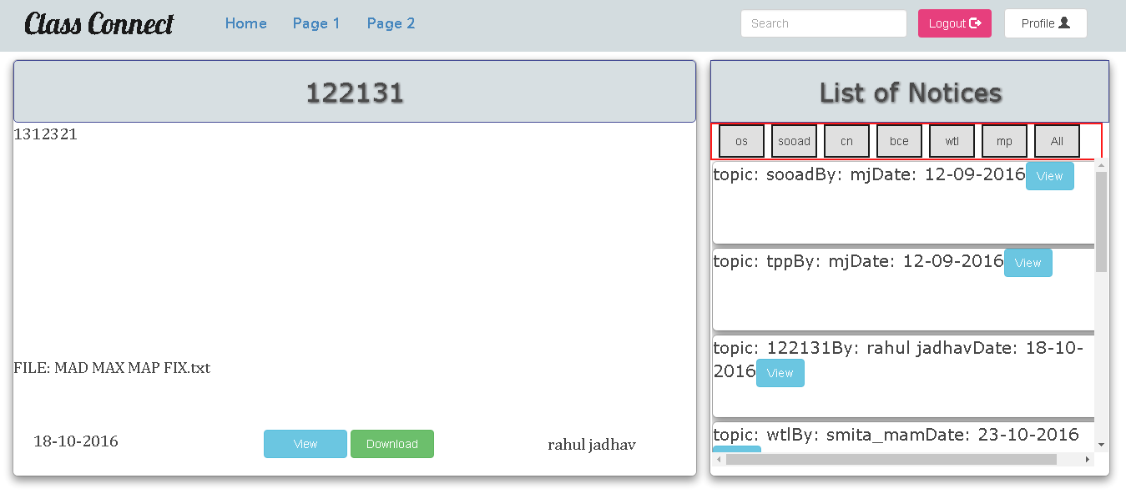

**TEACHER PORTAL**

**//Creates a new notice; views previous notices he/she posted in side pane**

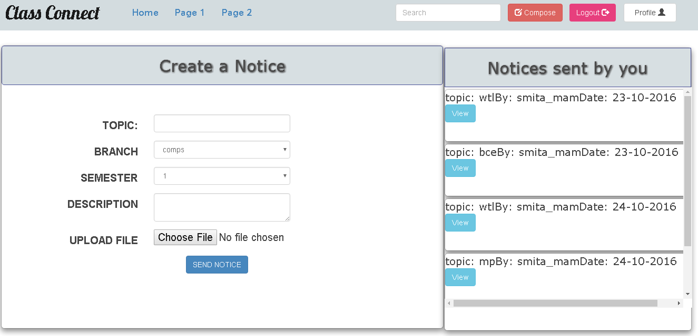

**6.2 SUBMISSION MODULE**

**STUDENT PORTAL**

**//Student successfully logs in**

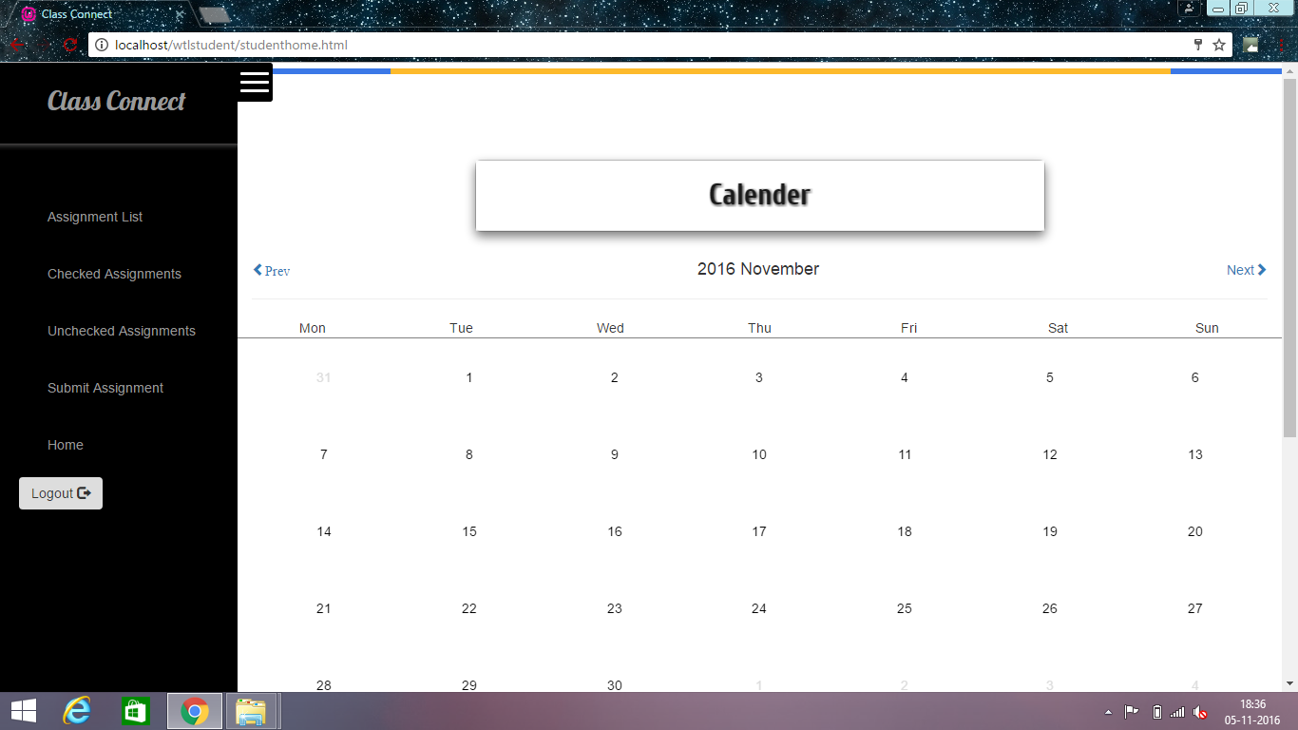

**//Students assignment counter**

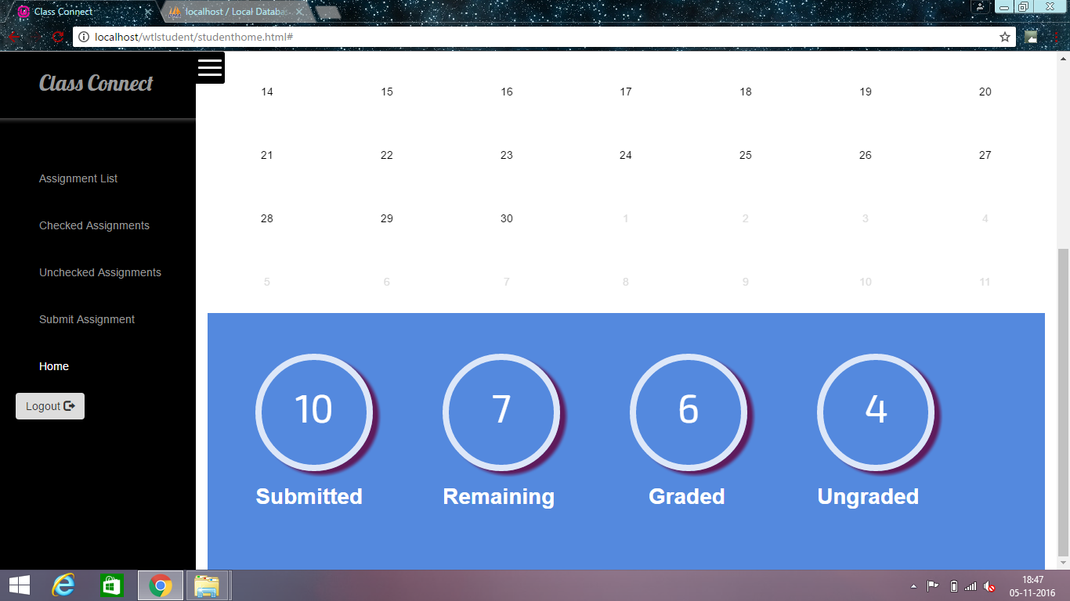

**//Views all pending assignments**

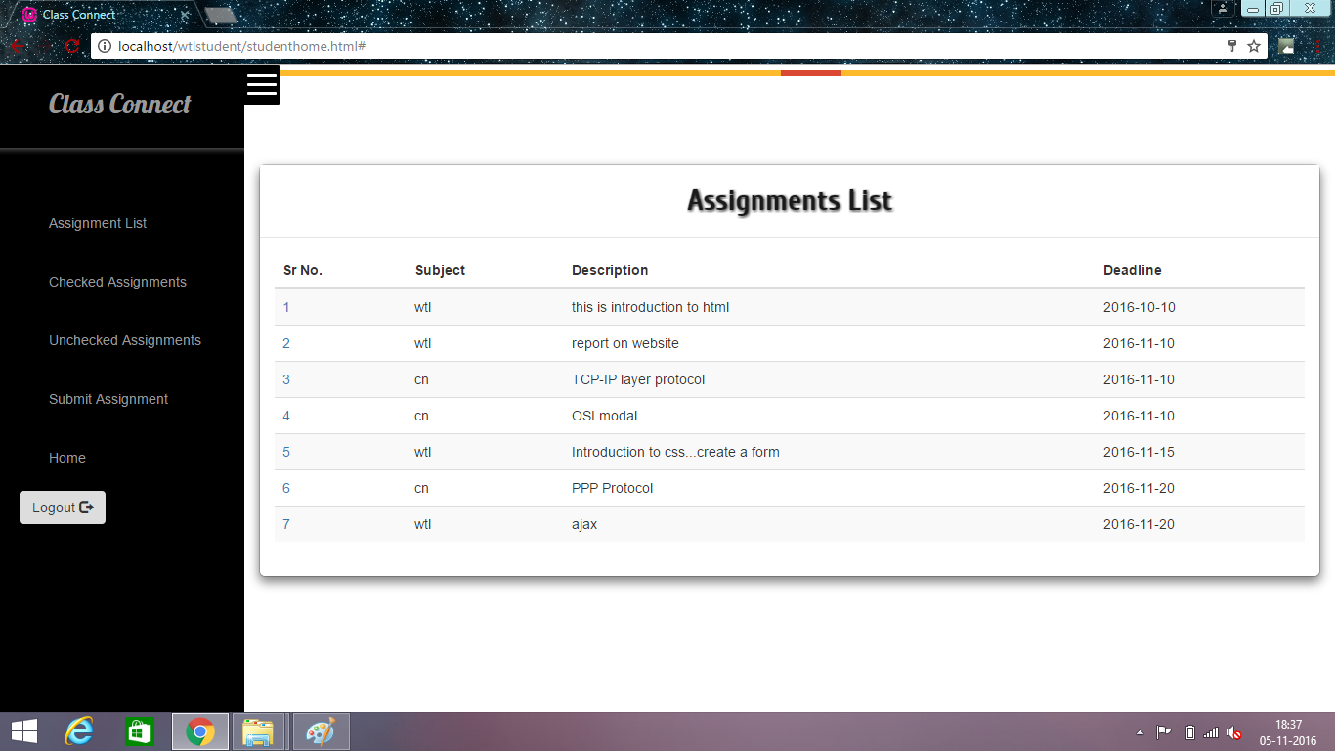

**//Views a particular assignment**

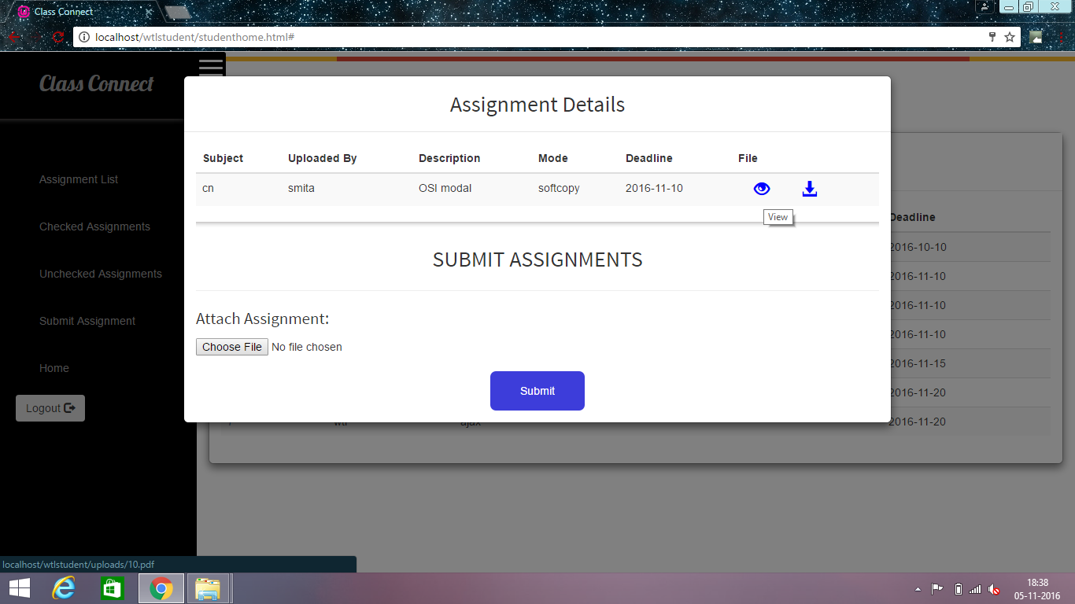

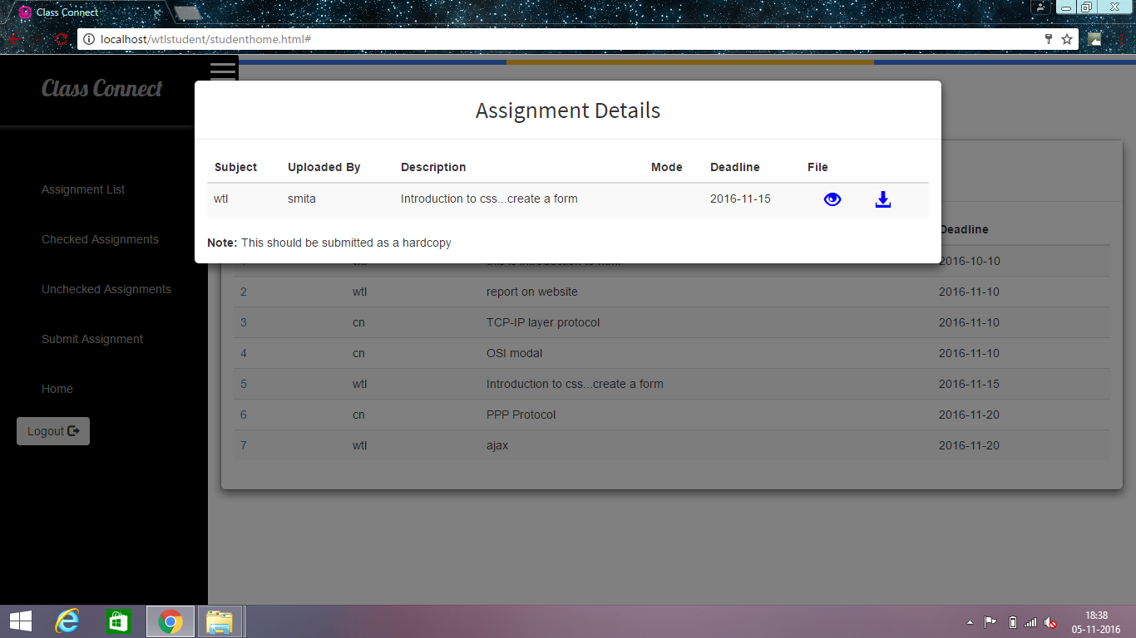

**//Views grades for all checked assignments**

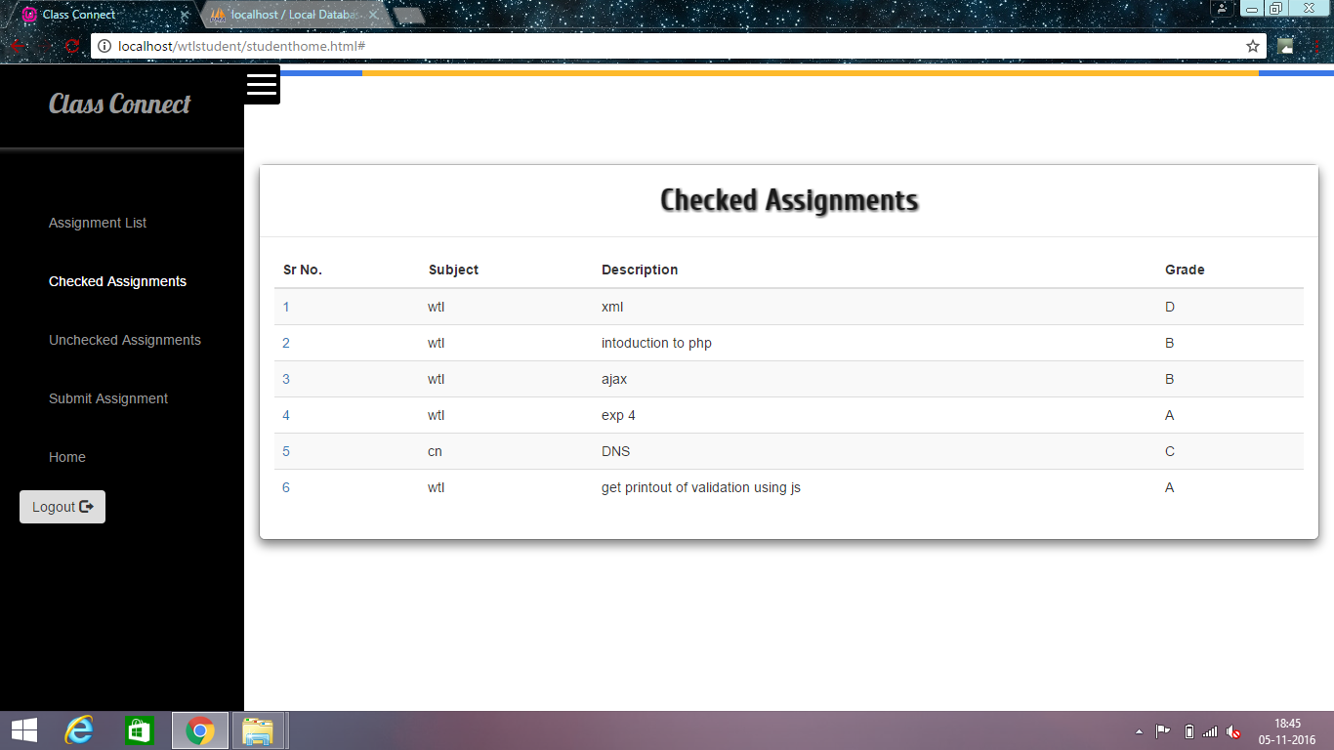

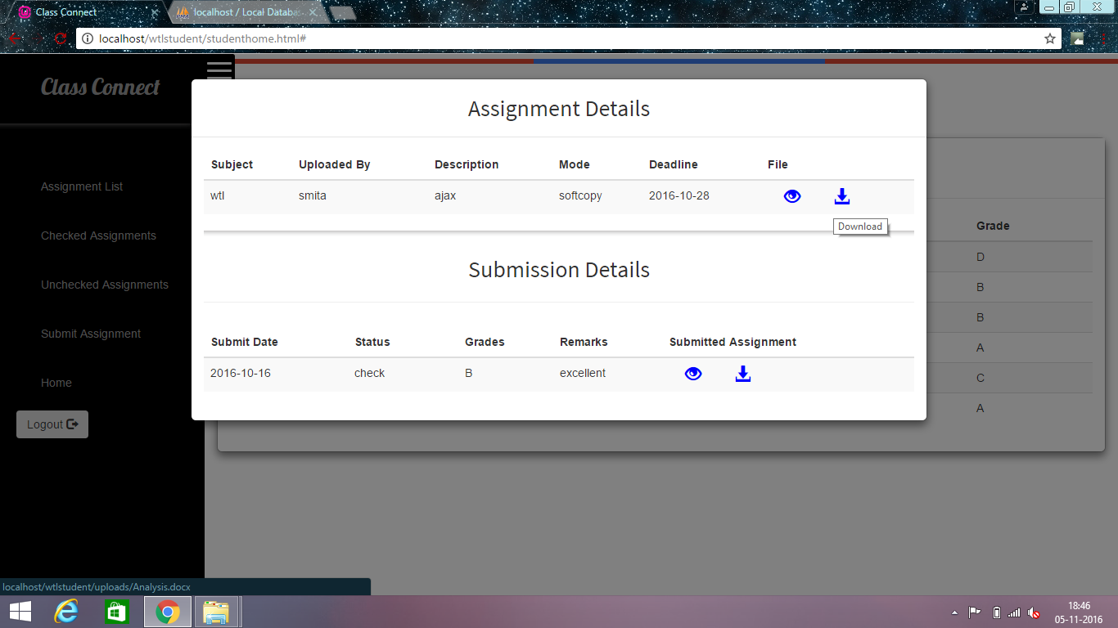

**//Views all unchecked assignments**

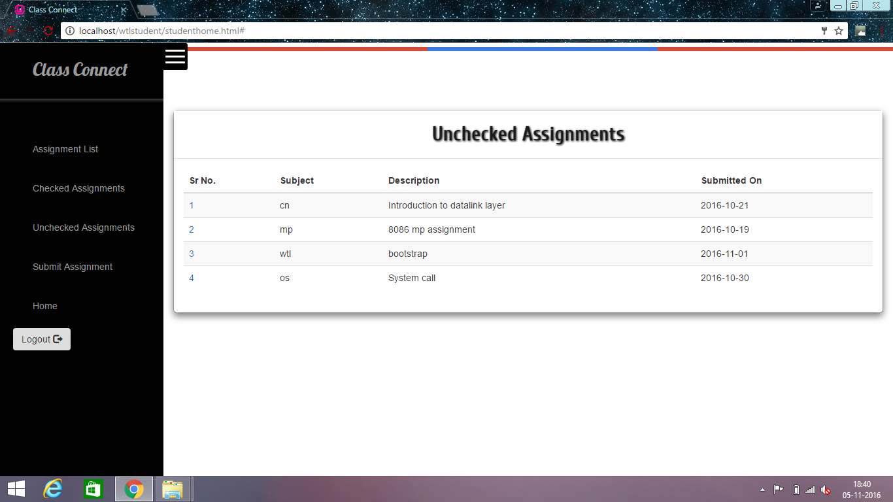

**TEACHER SIDE**

**//Teacher successfully logs in**

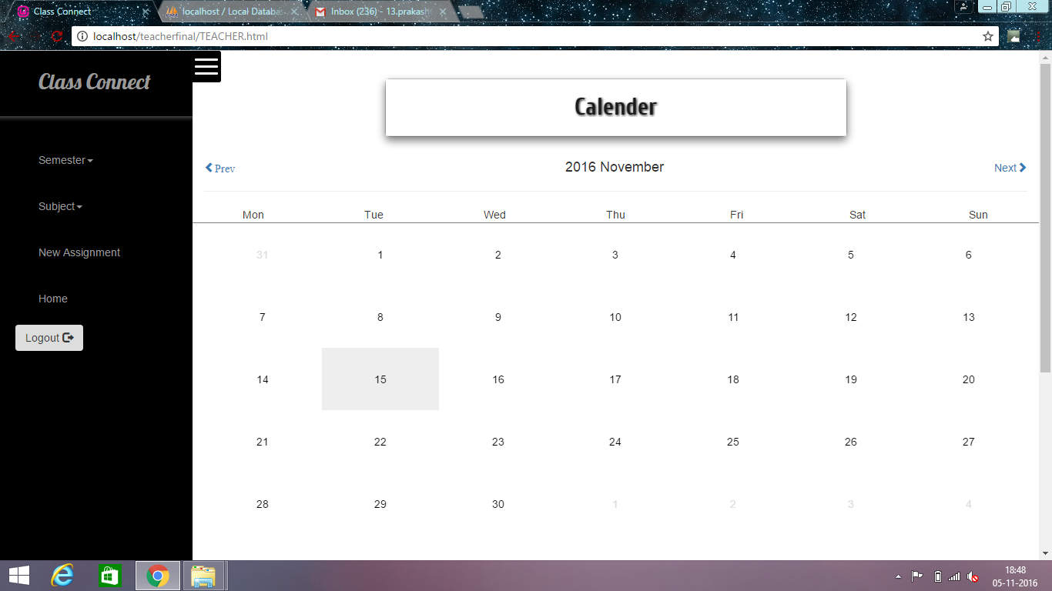

**//Teacher selects Semester, selects Subject and view assignments**

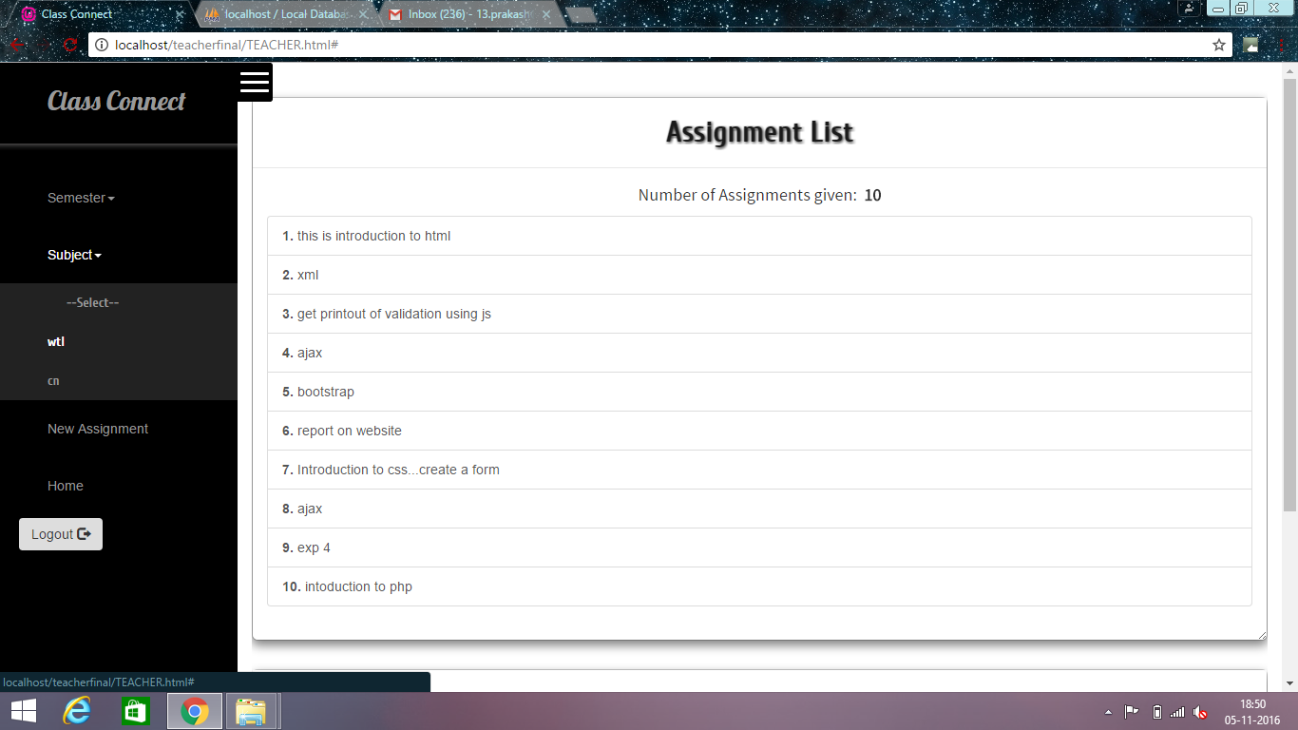

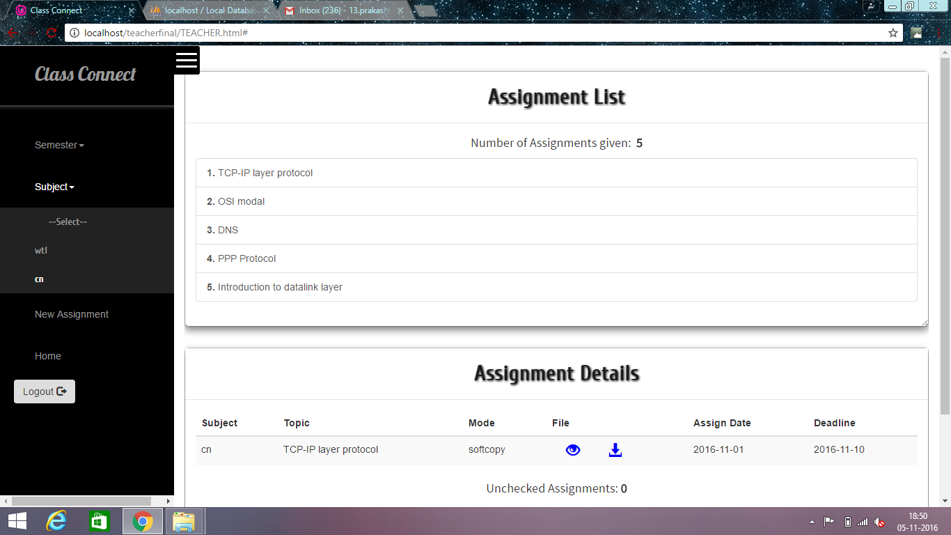

**//Teacher grades an assignment**

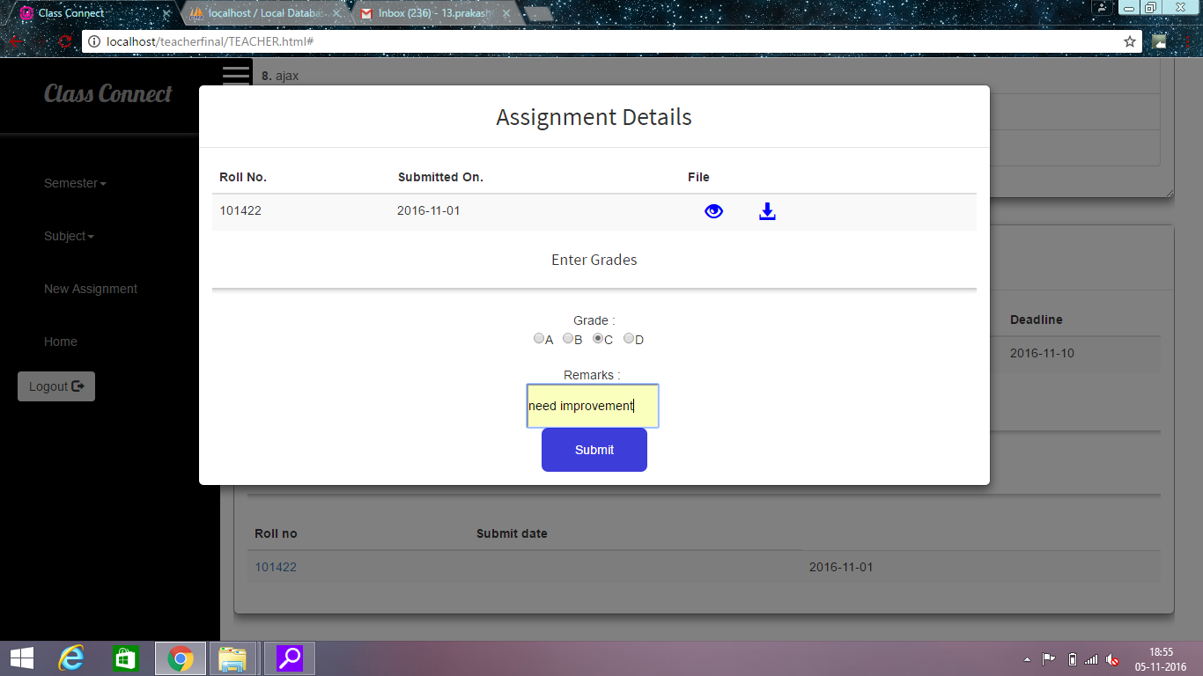

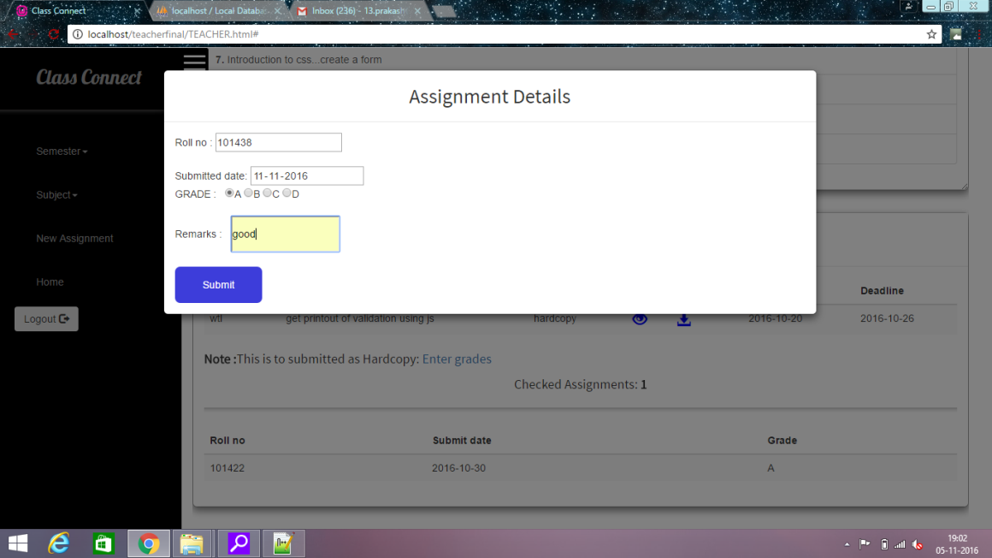

**//Teacher creates a new assignment question**

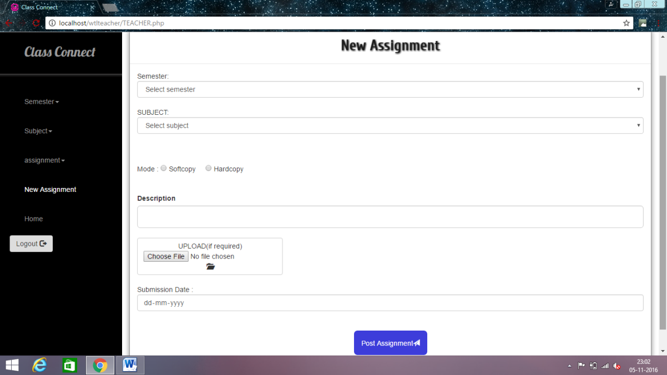

**6.3 FORUM MODULE**

**//Home page**

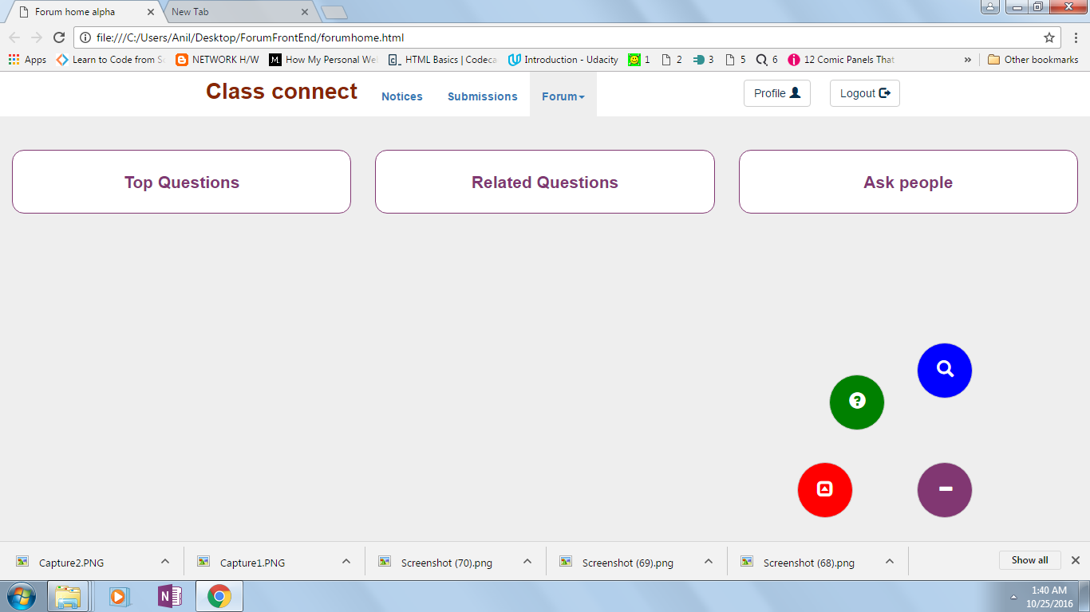

**//Ask a question**

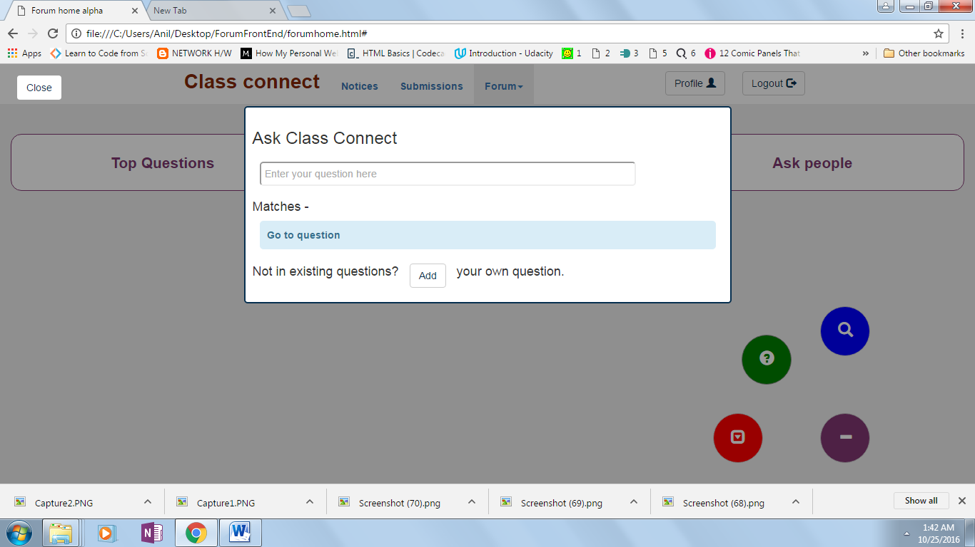

**//Search for related questions**

